 | Tonbridge and Malling Local Plan  Publication Stage Representation Form | Ref: (for official use only)

The Regulation 19 Local Plan consultation runs for six weeks from 11th September 2026 to 11.59pm on 26th October 2026. You can return this form to the Planning Policy Team at Tonbridge and Malling Borough Council, Gibson Building, Gibson Drive, Kings Hill, West Malling, Kent, ME19 4LZ.
Alternatively, you can return the form by email to localplan@tmbc.gov.uk.
Data protection and confidentiality
We are required to publish and make publicly available all comments submitted in response to this consultation. As such, we are unable to accept anonymous representations or representations from individuals who do not wish for their comments to be made public. Please note that representations submitted to the Council cannot therefore be treated as confidential.

In accordance with Regulation 22(1)(c) of the Town and Country Planning (Local Planning) (England) Regulations 2012, all representations received during the Regulation 19 Publication consultation will be submitted to the Secretary of State. This requires the Council to make publicly available copies of all representations received, together with the name of the individual submitting the representation and, where applicable, the organisation they represent.

All other personal information, including postal addresses, email addresses and telephone numbers, will remain confidential and will not be published.

As responses will be published, respondents are asked to ensure that all representations are respectful and appropriate. Comments that are racist, derogatory, offensive or inflammatory in nature should not be submitted.

Information about how the Council processes personal data can be found in the Data protection policy https://www.tmbc.gov.uk/council/data-protection-policy Please also note that information held by public authorities is subject to the provisions of the Freedom of Information Act 2000 and the Environmental Information Regulations 2004. Information may be disclosed in response to a request where it is appropriate and lawful to do so.

Please provide your details below to confirm acceptance of our privacy notice

Name:
Signature: | Date:
This form has two parts:
Part A – Personal Details. This only needs to be completed once if you wish to make more than one representation and representations are returned together.
Part B – Your representation(s). Please fill in a separate Part B form for each matter you wish to make a representation on.
We have also published guidance to assist you in completing this form. This can be accessed via https://reg19tmbcconsult.commonplace.is where you can alternatively complete your representation(s). Completing your representation(s) via our consultation platform is our preferred way for you to take part in the consultation.
The Planning Inspectorate have also released a guidance note on how to complete the form. https://www.gov.uk/government/publications/model-representation-form-for-local-plans/model-representation-letter-for-local-plans
Late representations
Representations received after the consultation deadline will be recorded as late representations. The Council is not obliged to treat these as duly made representations. However, late representations will be retained and forwarded to the Secretary of State as part of the submission documentation, clearly identifying them as having been received after the consultation period closed. The weight to be given to late representations is a matter for the appointed Planning Inspector.
Part A - This needs to be completed once if more than one Part B responses are returned together
 |  | - Personal Details |  | - Agent’s Details  (if applicable)
If an agent has been appointed by you, please complete only the Title, Name and Organisation (if applicable) in the boxes below (in Column 1), but complete the full contact details of the Agent in Column 2.
Title
First Name
Last Name
Job Title (if relevant)
Organisation (if applicable)
Address
Post Code
Telephone Number
Email Address

Part B – Please use a separate Part B form for each representation | Ref: (for official use only)

1: To which part of the Local Plan does this representation relate to?
This is important as it will be assessed by the Planning Inspector against the stated policy/section/site allocation. Reminder: If you would like to comment on more than one matter in the Plan, please complete a separate Form B for each matter you wish to make a representation on. We appreciate this takes additional time, but the Inspector requires comments to be submitted in this format.

Paragraph (please tick) |  | Policy |  | Policies Map

Which Chapter or Annex does this representation relate to?  (e.g Chapter 4) |  | Chapter 7
Which paragraph or Policy or aspect of the Policies Map would you like to make a representation on?  (e.g Paragraph 4.1 or Policy CC1) |  | NE2 National Landscapes
If your representation relates to a site allocation, please state which site. Please note you will need to make a representation for each site you wish to comment on.  (e.g. Site AN1) |  | BG1

2: Do you consider the Local Plan to be legally compliant? (Please tick)
Yes |  | No |  | Unsure

3: Please provide your comments here. Please also provide a summary of any attachments, such as supplementary evidence, submitted alongside your representation.
There are serious concerns about the physical impact on the North Downs National Landscape of those parts of the BG1 site that are within the NDNL, but also on the harm to the setting of the NDNL, and views into and out of the NDNL

Question 4: Do you consider the Local Plan to be sound? (Please tick)
Yes |  | No |  | Unsure

5: If you do not consider the Local Plan to be sound, please specify on what grounds (please select one option).
Positively Prepared |  |  | Consistent with National Policy
Justified |  |  | Unsure how to answer
Effective

6: Please provide your comments here. Please also provide a summary of any attachments, such as supplementary evidence, submitted alongside your representation.
We believe the Local Plan is unsound because the serious harm to the NDNL , and the impact on its setting, makes this site undeliverable and unavailable. Without the 2000 houses planned for the site, TMBC cannot meet its Objectively Assessed Housing Needs (OAN) because so many of the 500 sites in the Call for sites have been ruled out already, and we believe for far less substantive reasons than are apparent on this site.

7: Please set out any modification(s) you consider necessary to make the Local Plan to be legally compliant or sound as relevant to the matter you have identified above. Please state why the modification you suggest will make the Local Plan legally compliant or sound. It would be helpful if you are able to put forward your suggested revised wording of any policy or text. Please be as precise as possible.
Because of the impact this site has on the NDNL, it needs to be ruled undeliverable, and the sequential testing re-applied to other sites across the Borough far more suited to development

Please note: In your representation you should provide succinctly all the evidence and supporting information necessary to support your representation and your suggested modification(s). You should not assume that you will have a further opportunity to make submissions. This is because, after this stage, further submissions may only be made if invited by the Inspector, based on the matters and issues he or she identifies for examination.
8: If your representation is seeking a modification to the plan, do you consider it necessary to participate in the examination hearing session(s)? (Please tick)
No, I do not wish to participate in the hearing session(s)
Yes, I wish to participate in the hearing session(s)

9: If you wish to participate in the hearing session(s), please outline why you consider this to be necessary?
TMBC Planning Officers and appointed Counsel cannot be trusted to present a balance and evidenced view, having reached a conclusion in 2016 that this site must be developed, and have paid no heed to the evidence then or that has come forward ever since.

Please note the Inspector will determine the most appropriate procedure to adopt to hear those who have indicated that they wish to participate in the hearing session(s). You may be asked to confirm your wish to participate when the Inspector has identified the matters and issues for examination. If you wish to participate in the hearing, please ensure that you have provided your telephone number in Form A.

NORTH DOWNS NATIONAL LANDSCAPES (NDNL) (AONB)
BG1 Borough Green Gardens
This map below shows the relationship of BG1 to the North Downs National landscape. I have marked it with the individual land holding numbering from the Arup Greenbelt Assessment for clarity.
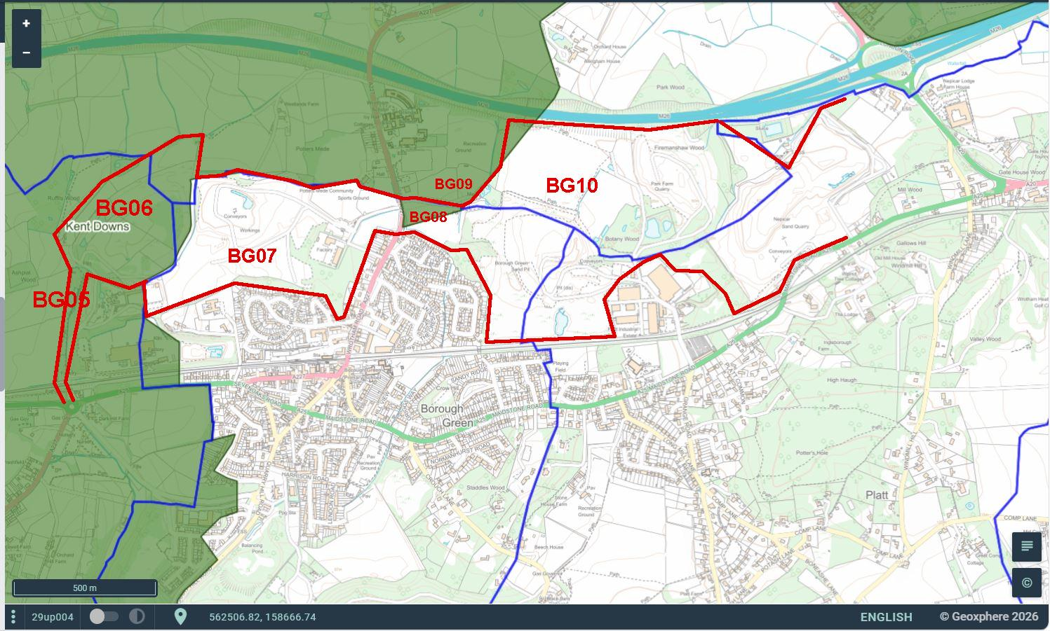
BG05 & BG06 Whilst there is no housing scheduled for BG05 and BG06, they are both wholly within the NDNL and there will have to be significant tree felling to allow construction of a Highways England Trunk Road, this will become the A25 Strategic Trunk Road.
Whilst this part of the site is not designated as Ancient Woodland, it is a significant area of long standing woodland, and its loss would clearly have a significant impact on the NDNL.
BG07 The site directly abuts the southern edge of the NDNL, and is in clear view of the North Downs, a significant element of the view from Wrotham Hill in the NDNL. (see image #3,4,5 below). Whilst bunding and tree planting could be used to mitigate this harm to the view, it would have to be so high and with trees so mature that it would cause opposing harm by limiting the views out of that part of the development.

BG08 - The Horsefield is such a crucial element in this report that I have included a separate close up map. This field is divided diagonally from south west to north east by a designated Public Right Of Way MR that is actually a desire line path that moves back and forth dependant of the flooding in the field. As it gets muddy, people walk on the grass to the side, and the path shifts north or south - it does not stay in one place. The planners think they can build on the southeast half of the field without impacting the setting of the NDNL in the n-west half of the field. (img #1 #2)
(image #1) PROW Map (image #2) Horsefield looking west
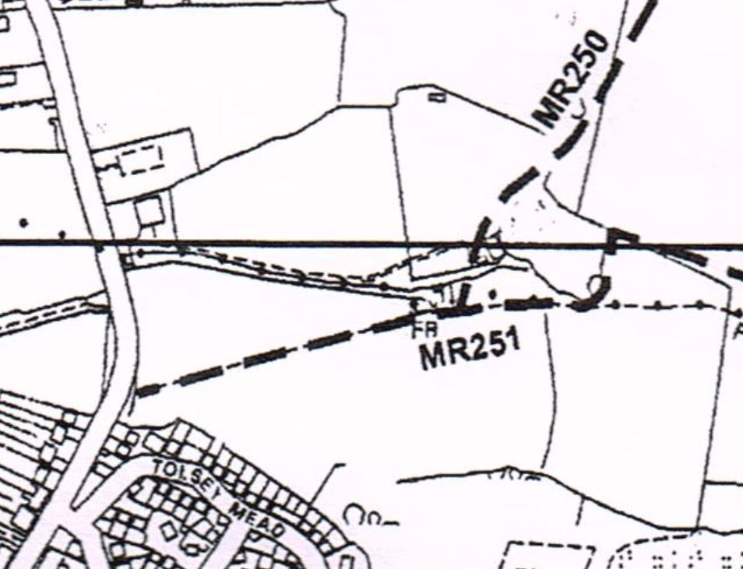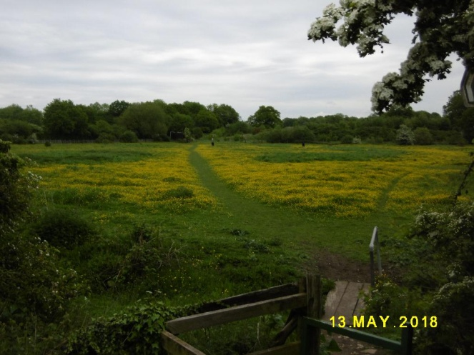
BG08 to BG10 Ancient Woodland On the PROW MR251 between the Horsefield BG08 and Borough Green Sandpit BG10 there is a significant tract of Ancient Woodland (image #6). Also listed are Botany Wood in the centre, and Firemanshaw Wood between Park Farm Quarry & Nepicar Sandpit
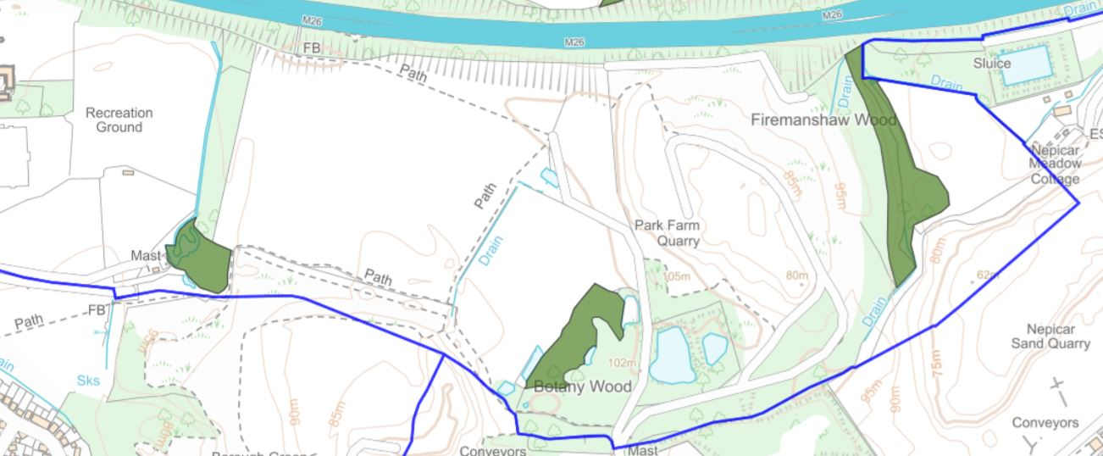

BG10 NORTH FIELDS also have a corner within the NDNL. This will have to be mitigated

Views of BG1 from the North Downs National Landscape
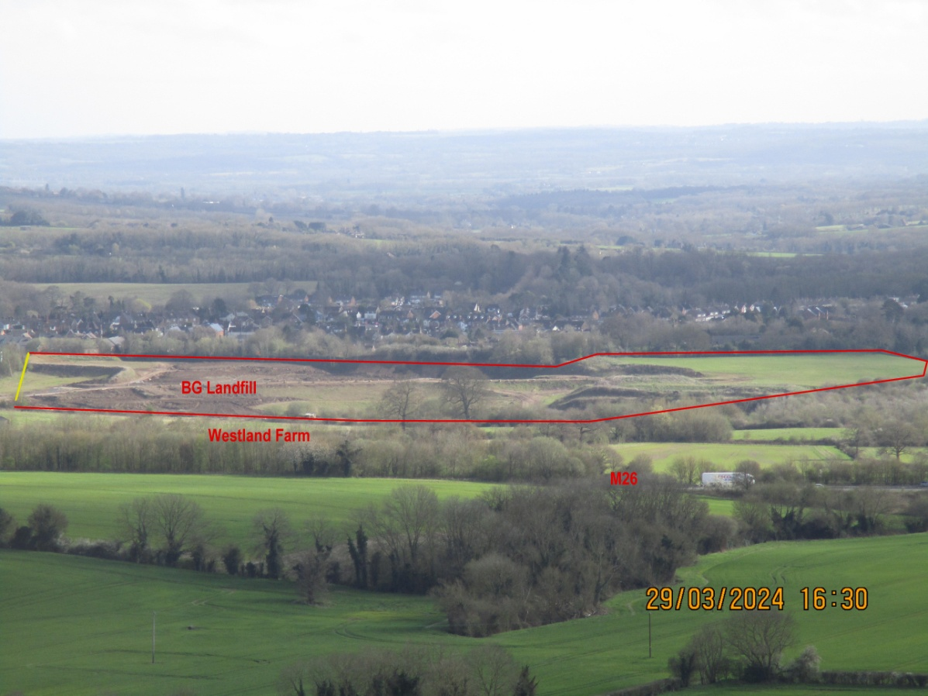 image #3
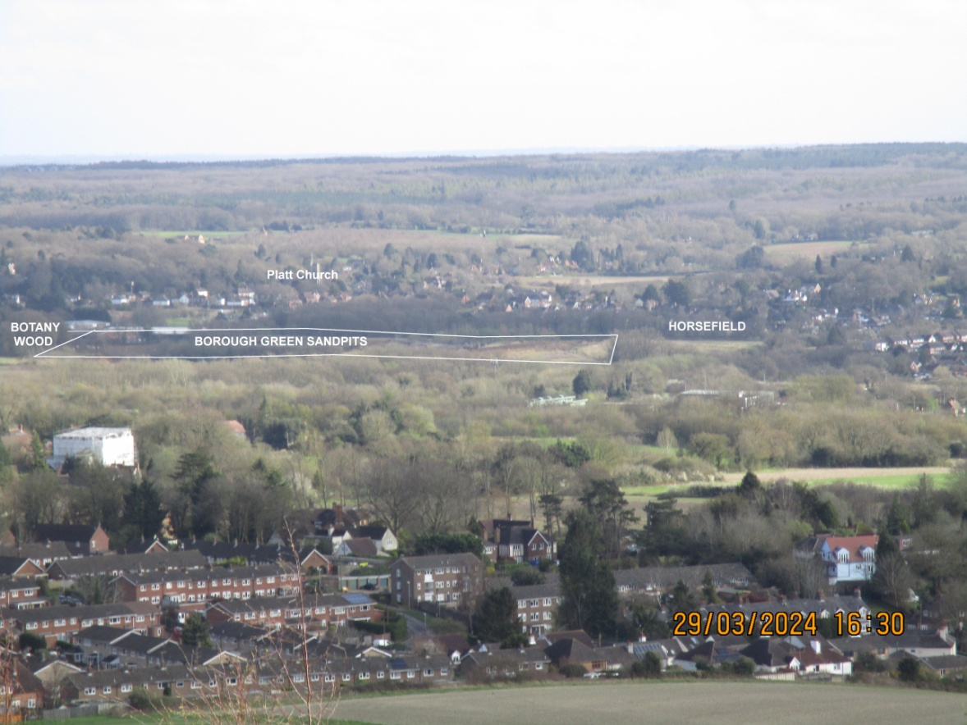 (image #4)
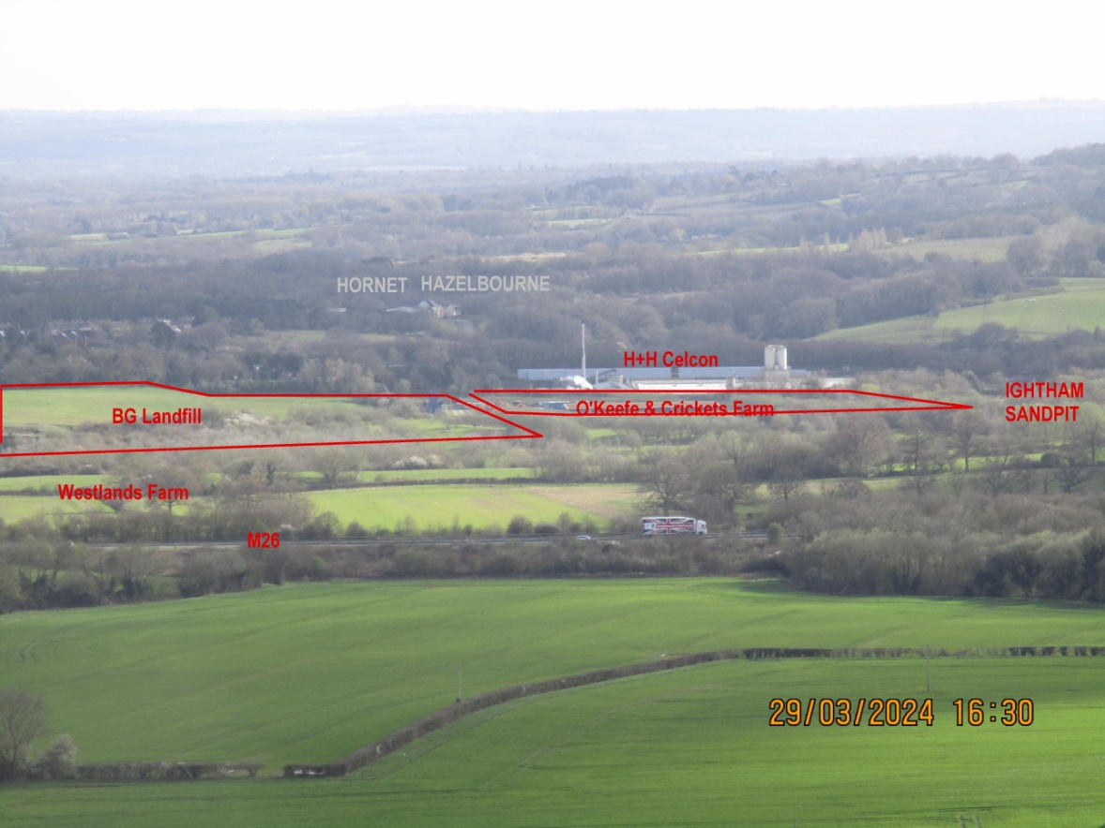 image #5
VIEWS OF THE NDNL FROM BG1 & Borough Green
Looking north across the Recreation Ground from Croudace Field
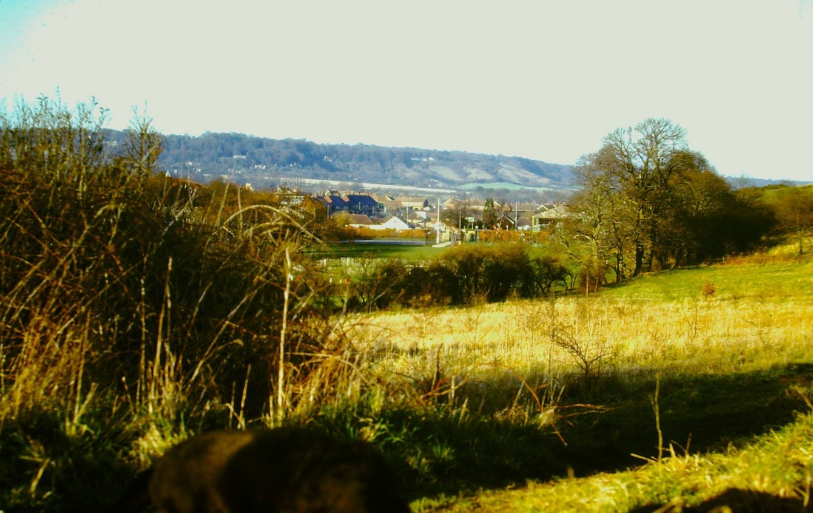

Looking north west across BG Sandpits and Ancient Woodland
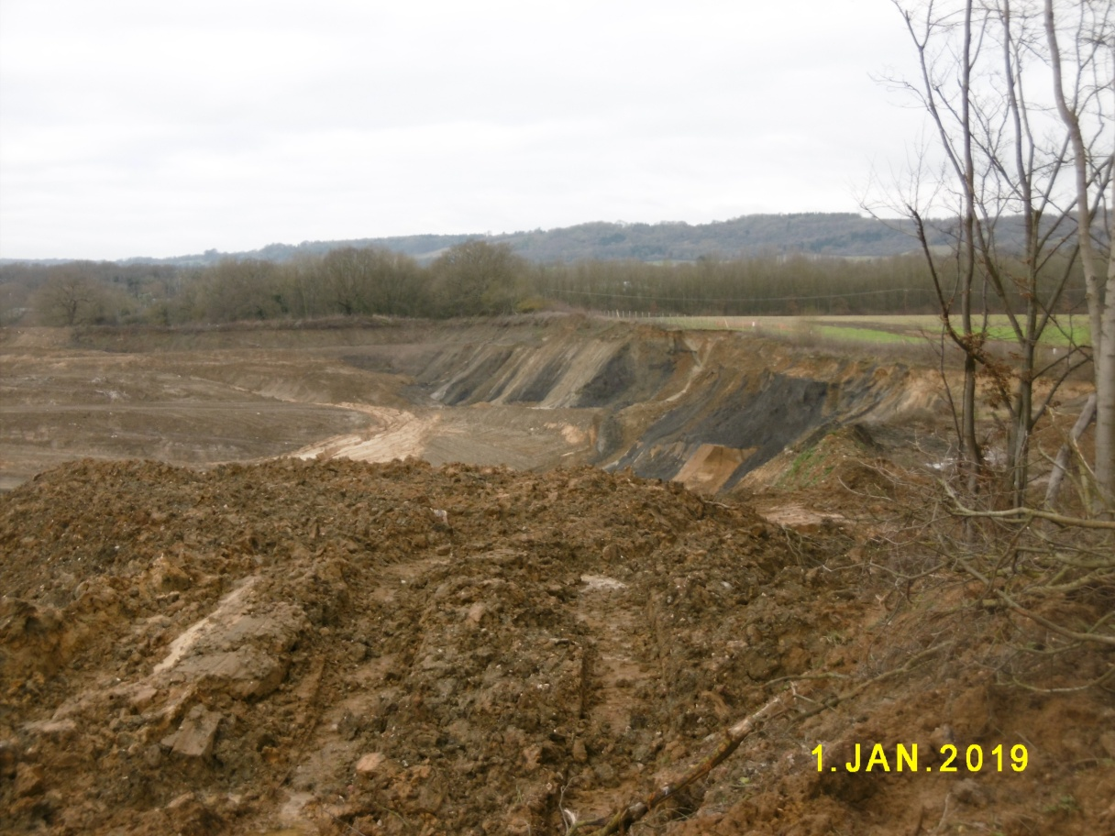
Looking north from Rock Rd in the heart of the Village
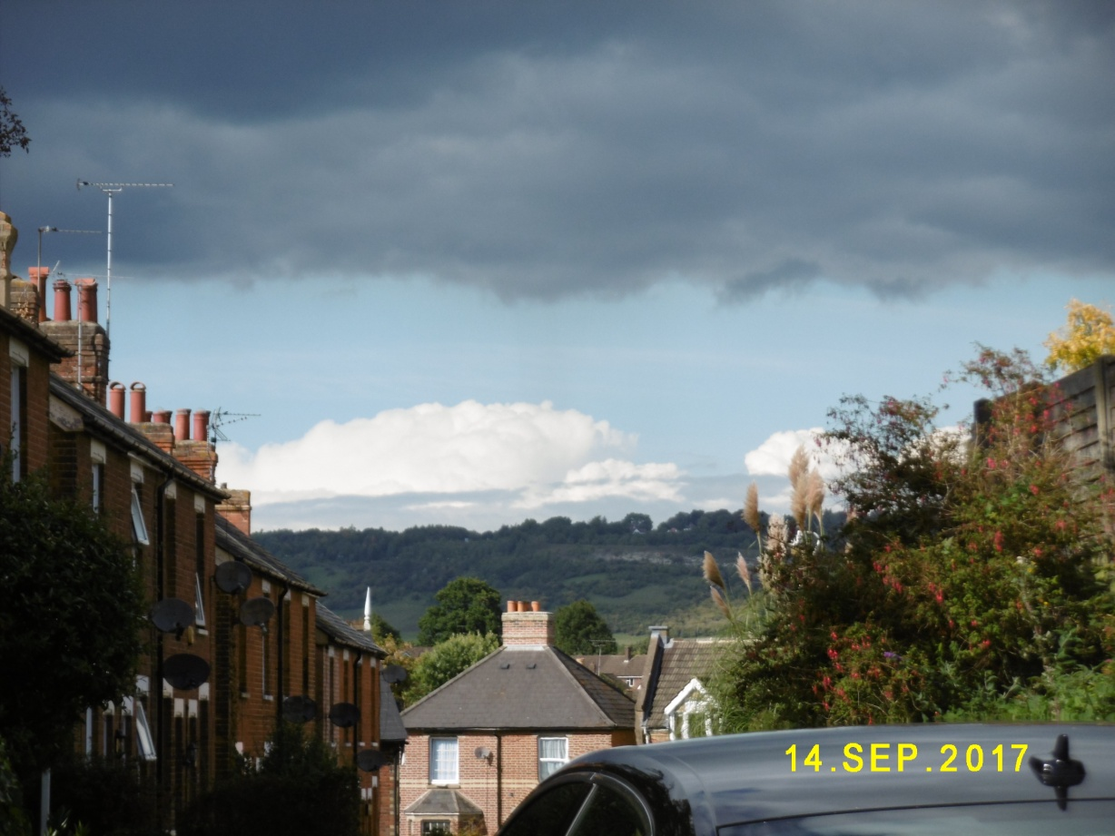

Looking north across Ightham Sandpit from the PROW MR244 at H+H Celcon
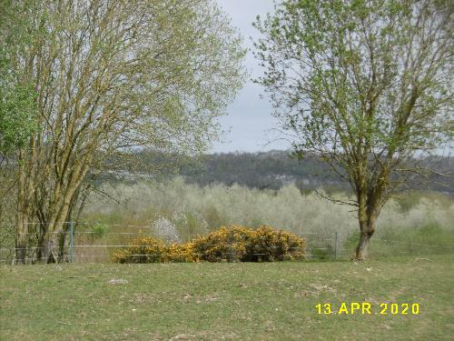
Looking North across the village from Crowhill
