The Regulation 19 Local Plan consultation runs for six weeks from 11th September 2026 to 11.59pm on 26th October 2026. You can return this form to the Planning Policy Team at Tonbridge and Malling Borough Council, Gibson Building, Gibson Drive, Kings Hill, West Malling, Kent, ME19 4LZ.  Alternatively, you can return the form by email to localplan@tmbc.gov.uk.  This form has two parts:  Part A – Personal Details. This only needs to be completed once if you wish to make more than one representation and representations are returned together.  Part B – Your representation(s). Please fill in a separate Part B form for each matter you wish to make a representation on.  We have also published guidance to assist you in completing this form. This can be accessed via https://reg19tmbcconsult.commonplace.is where you can alternatively complete your representation(s). Completing your representation(s) via our consultation platform is our preferred way for you to take part in the consultation.  The Planning Inspectorate have also released a guidance note on how to complete the form. https://www.gov.uk/government/publications/model-representation-form-for-local-plans/model-representation-letter-for-local-plans  Late representations  Representations received after the consultation deadline will be recorded as late representations. The Council is not obliged to treat these as duly made representations. However, late representations will be retained and forwarded to the Secretary of State as part of the submission documentation, clearly identifying them as having been received after the consultation period closed. The weight to be given to late representations is a matter for the appointed Planning Inspector.  Part A - This needs to be completed once if more than one Part B responses are returned together  Part B – Please use a separate Part B form for each representation | Ref: (for official use only)
   | Tonbridge and Malling Local Plan  Publication Stage Representation Form | Ref: (for official use only)
  Data protection and confidentiality
  We are required to publish and make publicly available all comments submitted in response to this consultation. As such, we are unable to accept anonymous representations or representations from individuals who do not wish for their comments to be made public. Please note that representations submitted to the Council cannot therefore be treated as confidential.
  In accordance with Regulation 22(1)(c) of the Town and Country Planning (Local Planning) (England) Regulations 2012, all representations received during the Regulation 19 Publication consultation will be submitted to the Secretary of State. This requires the Council to make publicly available copies of all representations received, together with the name of the individual submitting the representation and, where applicable, the organisation they represent.
  All other personal information, including postal addresses, email addresses and telephone numbers, will remain confidential and will not be published.
  As responses will be published, respondents are asked to ensure that all representations are respectful and appropriate. Comments that are racist, derogatory, offensive or inflammatory in nature should not be submitted.
  Information about how the Council processes personal data can be found in the Data protection policy https://www.tmbc.gov.uk/council/data-protection-policy Please also note that information held by public authorities is subject to the provisions of the Freedom of Information Act 2000 and the Environmental Information Regulations 2004. Information may be disclosed in response to a request where it is appropriate and lawful to do so.
  Please provide your details below to confirm acceptance of our privacy notice
  Name: Mike Taylor
  Signature: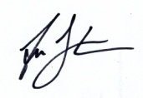 | Date: 28/02/2026
   |  | - Personal Details |  | - Agent’s Details  (if applicable)
  If an agent has been appointed by you, please complete only the Title, Name and Organisation (if applicable) in the boxes below (in Column 1), but complete the full contact details of the Agent in Column 2.
  Title |  | Councillor |  | N/A
  First Name |  | Mike
  Last Name |  | Taylor
  Job Title (if relevant) |  | Chairman Borough Green Town Council  Cabinet Member for Planning TMBC
  Organisation (if applicable) |  | Borough Green Town Council  Tonbridge & Malling BC
  Address |  | 41 Maidstone Rd  Borough Green  Kent
  Post Code |  | TN15 8BQ
  Telephone Number |  | 01732 882880
  Email Address |  | Mike.taylor@boroughgreen.gov.uk  Mike. taylor@tmbc.gov.uk

1: To which part of the Local Plan does this representation relate to?
This is important as it will be assessed by the Planning Inspector against the stated policy/section/site allocation. Reminder: If you would like to comment on more than one matter in the Plan, please complete a separate Form B for each matter you wish to make a representation on. We appreciate this takes additional time, but the Inspector requires comments to be submitted in this format.

Paragraph (please tick) |  | Policy |  | Policies Map

Which Chapter or Annex does this representation relate to?  (e.g Chapter 4) |  | 13 Infrastructure
Which paragraph or Policy or aspect of the Policies Map would you like to make a representation on?  (e.g Paragraph 4.1 or Policy CC1) |  | INF 1 INF 2
If your representation relates to a site allocation, please state which site. Please note you will need to make a representation for each site you wish to comment on.
(e.g. Site AN1)

2: Do you consider the Local Plan to be legally compliant? (Please tick)
Yes |  | No |  | Unsure

3: Please provide your comments here. Please also provide a summary of any attachments, such as supplementary evidence, submitted alongside your representation.
Policy INF1
Para 1 asserts that "Development proposals must demonstrate , having regard to the cumulative and cross-boundary impacts, that sufficient infrastructure, capacity and services are available or will be delivered in a timely manner to support the development. New development must mitigate its impacts upon the existing infrastructure and service capacity."

The Local Plan clearly ignores the impact of new development on existing infrastructure shortages, and the main reason Members deferred the Plan was because they were not allowed to pay heed to existing infrastructure failings.

This applies to Traffic and Sewage, but most importantly Water Supply, where the estimated demand of the new housing vastly exceeds capacity. TMBC have already been engaged in conversation with Government about water supply issues, but have been ignored.

The Traffic studies are unsound because they do not reflect actual road use because they ignore existing failings. And to be sound every major junction in the Borough, and those in boundary areas need assessment.

Sewage capacity in Borough Green and its neighbours has been a problem for decades because our original 1928 system has never been upgraded, and there has been massive development in Borough Green area over the intervening years. We regularly have sewage breaches, either into people's homes and gardens, or into the Bourne River. Sewage detritus in the silt of Basted Millpond, originally discovered in a 2002 study now generates an annual infestation of Musca domestica and lesser houseflies Fannia canicularis in the small housing development at Basted Mill. The local sewage system is hugely overcapacity now, and yet TMBC's plan is to put the effluent from the 2000 (3000) houses at Borough Green Garden City through this collapsing system.
Drive through Platt and Borough Green day or night and you will smell raw sewage at Askew Bridge, Maidstone Rd pumping station, Rock Rd junction, and Wrotham Rd adjacent to Tolsey Mead.

On the subject of Water Supply, all the water in the north of the Borough comes from the Greensand Ridge aquifer that runs east to west along the valley. Recent borehole levels demonstrate extremely low availability of supply. But what is also crucially important is that Ightham Sandpit to the west of Borough Green has been ilegally backfilled with hazardous waste, in an operation that neither KCC Minerals and Waste, nor the Environment Agency have any records of a landfill operation. But that sandpit is now mysteriously filled. Anecdotal evidence tells us this was filled with hazardous waste from the remediation at the old BP Terminal/Refinery at the Isles of Grain. The Southern Testing 2006 intrusive investigation commissioned by H+H Celcon confirms drums of unknown material, pipework, oily and smelly detritus. If this site leaches it will contaminate the aquifer.

Question 4: Do you consider the Local Plan to be sound? (Please tick)
Yes |  | No |  | Unsure

5: If you do not consider the Local Plan to be sound, please specify on what grounds (please select one option).
Positively Prepared |  |  | Consistent with National Policy
Justified |  |  | Unsure how to answer
Effective

6: Please provide your comments here. Please also provide a summary of any attachments, such as supplementary evidence, submitted alongside your representation.

7: Please set out any modification(s) you consider necessary to make the Local Plan to be legally compliant or sound as relevant to the matter you have identified above. Please state why the modification you suggest will make the Local Plan legally compliant or sound. It would be helpful if you are able to put forward your suggested revised wording of any policy or text. Please be as precise as possible.
1. Plans for housing in the future must take account of the impact on the existing infrastructure.
2 Water supply is a matter that can only be dealt with at government level - the funding needed is beyond any District Council or even developer.
3. Sewage capacity must be upgraded with two new pumping stations in the development feeding through a new line to the Ham Hill WwTW, and this could take the effluent from Wrotham and the north of Borough Green, easing the pressure on the existing main line
4. The Borough Green Relief road must be built in its entirety before development starts.

The traffic study fails to identify the juxtaposition of three roundabouts in a few hundred yards - the M26/A20 Nepicar Junction, the new roundabout access to the 200 truck Moto Lorry Park and services to the North, and the proposed roundabout connection to the Borough Green Relief Road.
Please note: In your representation you should provide succinctly all the evidence and supporting information necessary to support your representation and your suggested modification(s). You should not assume that you will have a further opportunity to make submissions. This is because, after this stage, further submissions may only be made if invited by the Inspector, based on the matters and issues he or she identifies for examination.
8: If your representation is seeking a modification to the plan, do you consider it necessary to participate in the examination hearing session(s)? (Please tick)
No, I do not wish to participate in the hearing session(s)
Yes, I wish to participate in the hearing session(s)

9: If you wish to participate in the hearing session(s), please outline why you consider this to be necessary?
I worked in the local quarrying industry, ran my own haulage company in the construction industry, have been a Parish Councillor since 2001, and a Borough Councillor since 2014, Cabinet Member for Planning since 2023.

I understand the desperate need for housing, and the Parish Council have suggested 3-400 houses just to the north of the village would be very useful, but even then it will stretch the infrastructure

Please note the Inspector will determine the most appropriate procedure to adopt to hear those who have indicated that they wish to participate in the hearing session(s). You may be asked to confirm your wish to participate when the Inspector has identified the matters and issues for examination. If you wish to participate in the hearing, please ensure that you have provided your telephone number in Form A.

THE SEWAGE HISTORY OF BOROUGH GREEN PLATT & SURROUNDING VILLAGES

A book on local history called a "Past & Present" by Frank Bangay, records this:
The Wrotham Urban District Council was formed in 1894. In 1911 they planned a main drainage scheme for Wrotham, Borough Green and Platt which was eventually completed in 1932.

We understand this ran from the west of Borough Green, following the A25 as far as the Maidstone Rd pumping station opposite the Recreation Ground, where it went north and followed the railway as far as Platt Industrial Estate where it rejoined the A25 at Whatcote Cottages, following it to Wrotham Heath and onward to Ham Hill Sewage Works. Wrotham was connected via a main following the A227 to Borough Green where it connected to the east/west main, probably at Western Rd.

The pipe used was 18" spun concrete, probably produced by Milton Pipes in Sittingbourne, but was made from Ordinary Portland Cement (OPC) being the days before Sulphate Resisting Cement (SRC) was developed. As a consequence it is vulnerable to sulphate attack from the effluent gases. Hydrogen Sulphides produce Sulphuric Acid when mixed with water, which dissolves both concrete and the reinforcing mesh.

WUDC Sewage System 1929 - 1932 copied from original WUDC/MUDC maps
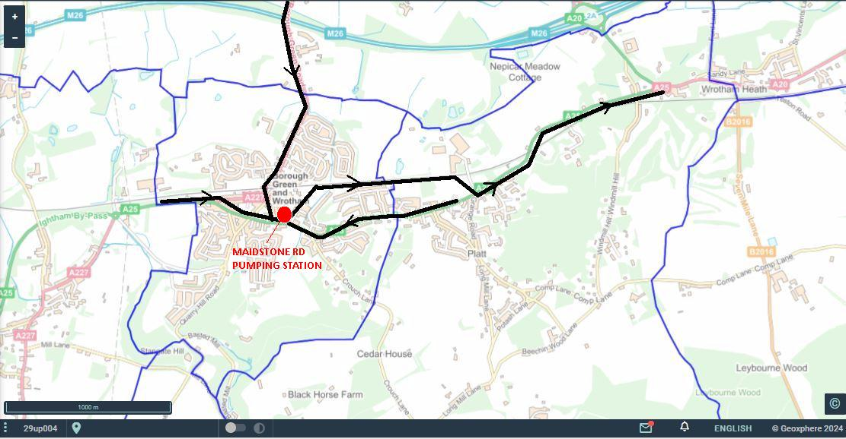

At this time the combined number of houses in the three villages was approximately 1071. Basted Pumping Station , was added in the late 60s after the Odhams floods, but the pipe blew out in Thong Lane in the early 2000s flooding back into Basted Millpond. In the mid '70s 1481 houses in Ightham, Plaxtol and Shipbourne were added with new pumping stations, all feeding into the same Maidstone Rd pumping Station and line to Ham Hill. ( I ran the ARC Concrete Plant that supplied the project)
The bridleway south of the Basted pumping station suffers breaches into gardens and the bridleway, and into the Bourne when it fails, and sewage from Plaxtol escapes.
Huge levels of building expanded BG, Platt & Wrotham to today's figures of 3240 + the 70s 1481 means we have a 100 year old system designed for 1071 houses now carrying sewage from 4721 properties.

It is worthy of note that Southern Water's submission to the Local Development Framework evidence in 2003 states quite clearly "No sewer capacity available".

1960s & 1970s
In the 1967 after the River Bourne burst its banks and flooded Basted Mill, a pumping station was installed here for the new housing development that replaced the destroyed Papermill, pumped through Basted Mill , up Thong Lane to the Crowhurst Rd pumping Station, and crossed Borough Green Rec to the Maidstone Rd Pumping Station. The Crowhurst Rd pump collected all the sewage from the New Woodlands and Valleyview Estates.

Shortly after this a new pumping station was installed near the Spoute Recreation Ground in Plaxtol, collecting sewage also from Shipbourne and Dunks Green, and sending it up a new pipe installed on the banks of the Bourne River to join the Basted Pumping Station, and thence to Borough Green.

At the same time the whole of Ightham and Ivyhatch were put on main drainage and connected through a new Ightham pumping station on Borough Green Rd. From there a new line crossed Darkhill Farm, joined into the 1929 line on Sevenoaks Rd, and thence to the Maidstone Rd Station

Southern Water Borough Green & District Sewage from late 1970s
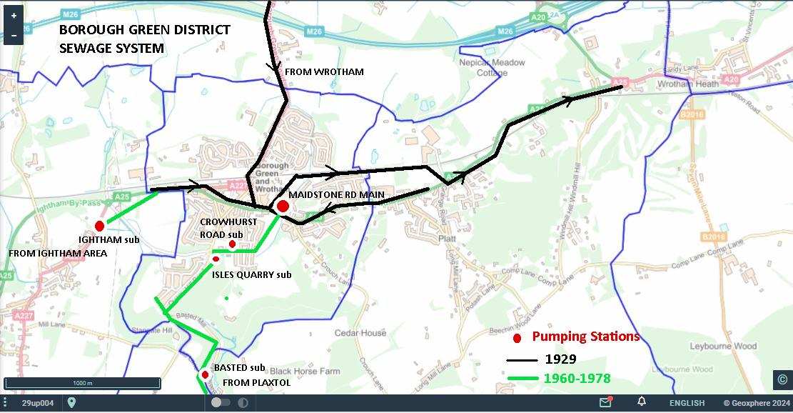

1970s Crossroads Whilst I have no records, I was aware of a large sinkhole opening up in the mid 1970s near the crossroads, caused by a "washout" when the sewage main burst some 15m below ground.

1990s Maidstone Rd Recreation Ground manhole burst in the carpark flooded the Rec which had to be closed for several weeks for decontamination. The sewage flowed down the River Bourne into Basted Millpond, and a Basted Mill pond survey in 2002 showed high levels of sewage residue in the pond silt and banks.

2008 THONG LANE & MAIDSTONE RD
In about 2008 the line from Basted blew out in Thong Lane, and sewage flooded back down the hill into the Bourne and Basted Mill Lake. Also in 2008 a small sinkhole opened up above the sewer line on Maidstone Rd junction with Hillview

2012/ 13 /14/15 etc Sevenoaks Rd multiple breaches adj Church View Sevenoaks Rd. When Valleyview estate was built, the sewer line was connected into the line serving Orchard House and Church View rather than a direct feed along the Red Lion footpath to join the main line. Multiple illegal surface water connection exacerbate the problem, and every time it rains sewage bursts out of the manhole and floods multiple properties.

2013 Rock Rd junction. An alleged "fatberg" blocked the Rock Rd line into the main sewer, causing flooding across Sevenoaks Rd. At the same time, surface water from Westbank Lodge Drive overfilled the Sevenoaks Rd surface drainage, and sewage blew back from a manhole in the Mews Cottages next to the Red Lion, flooding one house.

2013/14/15 HILLVIEW CLOSE
In late December 2013 the Maidstone Rd pump power failed, and the backup generator failed to start (APPENDIX1). The subsequent flood inundated gardens and properties in Hillview Close and Maidstone Rd. Hillview Close is the lowest point adjacent to the pump, but they were fitted with Non-Return Valves in 2015 to keep sewage out of the houses. Multiple failings of the pumping station caused sewage floods in 2013, 2014 & 2015.

2014- 51 Maidstone Rd - also adjacent to the main pumping station, this property has flooded on several occasions with sewage back wash, now fitted with sealed manholes.

BASTED LANE 2013 - 2016
Multiple blowouts of manhole on pressurised line from Plaxtol when the Basted Pump fails. This floods a residents garden on the unmetalled section of Basted Lane, and straight into the Bourne River. The pipelin runs along the bank of the Bourne from Plaxtol Spoute (APPENDIX 3)

2014/15 CROWHURST RD In 2013 a new pumping station was added to feed the sewage from Isles Quarry 171 houses into the line from Basted to Crowhurst Rd. This caused overloading of the Crowhurst pump leading to multiple failures. When it was finally repaired, it increased the pressure that triggered the Maidstone Rd blowouts (APPENDIX 2)

2020 Recreation Ground Maidstone Rd Failure of the Maidstone Rd pumps caused a pressure increase in the line from Crowhurst/Isles Quarry/Basted/Plaxtol, causing the pipe to burst, and blowing sewage through the tarmac where it flooded the Rec.

2020 Borough Green Rd Wrotham. Just south of the M26 overbridge, a manhole blew out and sewage flooded down the road - destination unknown, except some will have gone into road drains and ito the River Bourne catchment north of BG

2021 Recreation Ground x2. Over pressure from Crowhurst Rd/Isles Quarry pump blew a manhole when the Main pump failed - again flooding the Rec and the Bourne. This happened twice

2021 Sandy Ridge. SW admitted that the Maidstone Rd pump station motors and pumps (1929) were past their useable life, and replaced them and the control gear. When the new pumps were started it immediately blew out the main pipe in a garden on Sandy Ridge, where it flowed into the Bourne and through the Rec. Multiple repairs and trials followed, and at least 5 more breaches.

2021 Askew Bridge A25. An overnight BT crew discovered sewage in their telecomms manhole. Further investigation discovered a sinkhole under the A25 as big as a Transit Van. SW CCTV'ed the pipe, and discovered a major blockage caused by pipe rot and collapse of earth into the pipe. That earth washed away leaving the sinkhole. See "Sad Sorry Sewage Saga". One 10m section of pipe was replaced, and 300 metres was fibre glass lined. The road was closed for three months.
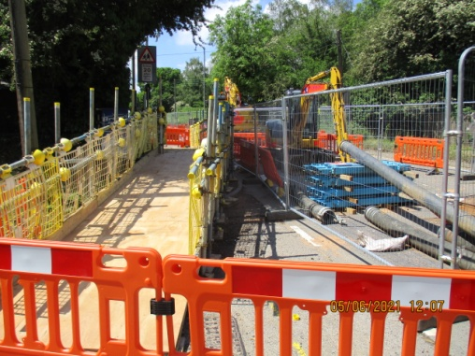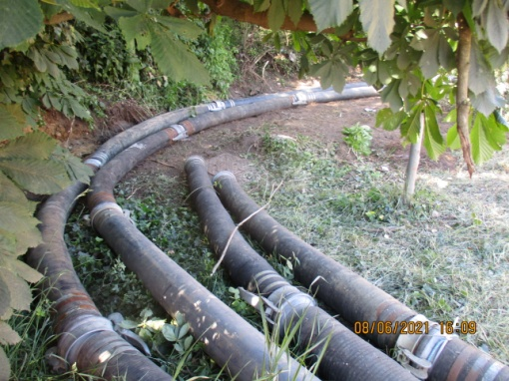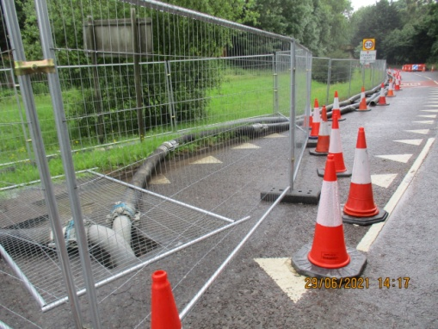

2022 Maidstone Rd, sewage burst at 121 Maidstone Rd, on the Platt back line.

2022 Crouch Lane/Maidstone Rd sewage breach floods main road, and surface water drains take sewage into the Rec

2024 Wrotham Rd adj Tolsey Mead - sewage breach - unknown cause.

2025 Maidstone Rd Platt Whatcote Cotts. A section of the 1929 pipe replaced because of concrete rot

Sewage bursting through tarmac and flooding Recreation Ground 2020
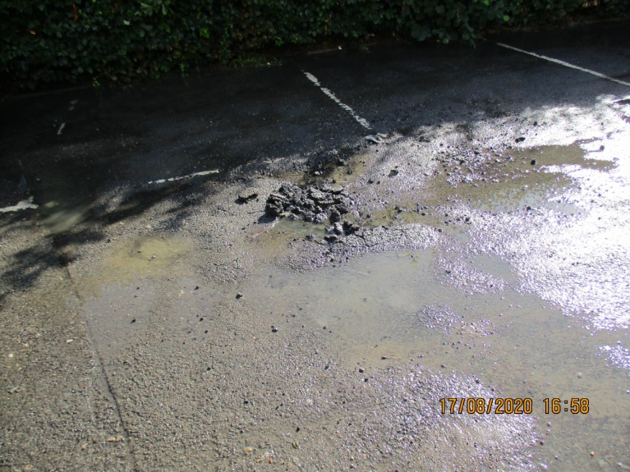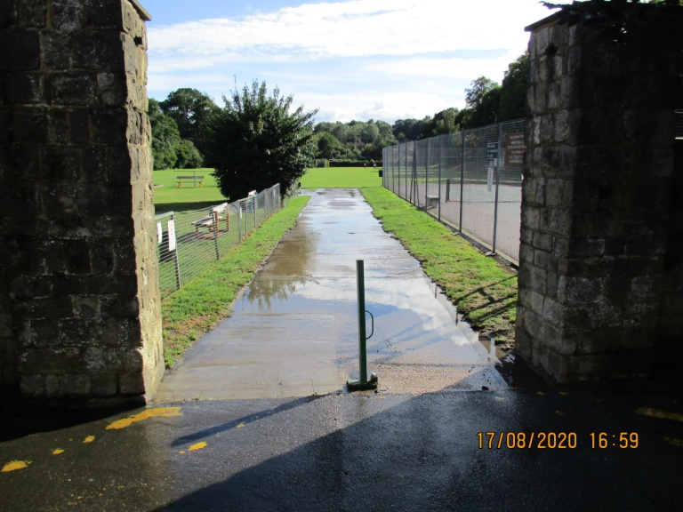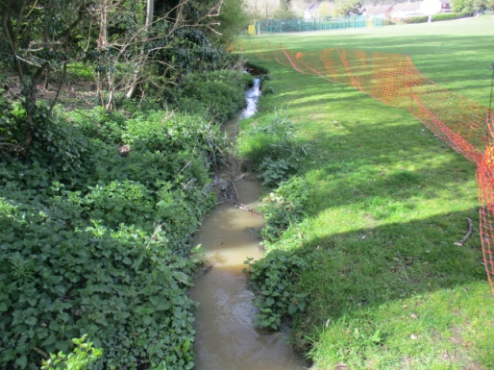

Sandy Ridge/Lingfield Rd, The pictures below show the front and rear gardens of the property involved. To be fair Southern Water did put a huge amount of resources into the repairs, and did an exemplary job of reinstatement.

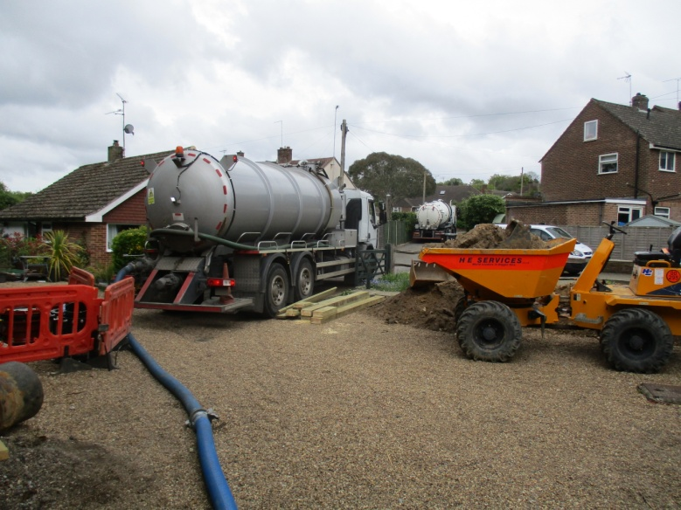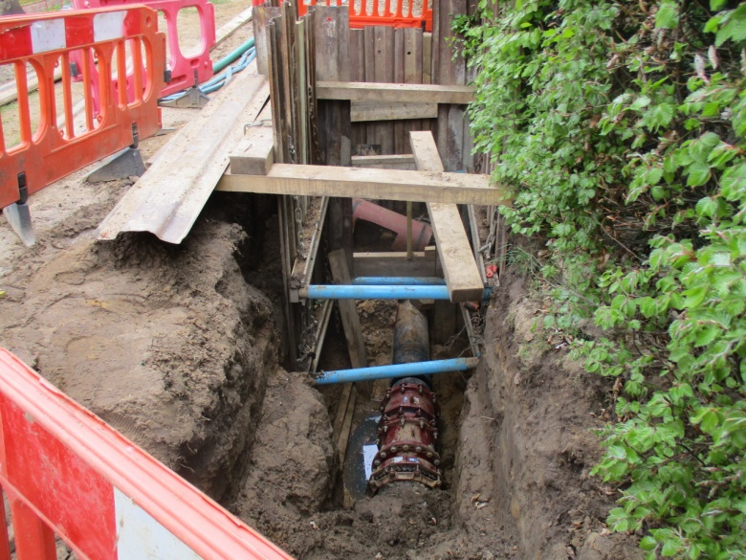

CONCLUSION.
The entire 1929 system needs replacing or relining, and new pumping stations and line to route Wrotham, North BG and any BGGC development around the existing system to join the main line at Wrotham Heath, possibly following a line north of the railway.

The problem exists because of decades of lack of investment, the near five-fold increase in properties added to the system, lack of surge storage tanks, and no telemetry between pumps - even when a station shuts down, the ones behind keep pumping until something bursts.

We believe serious contender for the source of the flies at Basted Mill, where decades of sewage spills have ended up in the Basted Millpond, the Bourne River and ultimately the Medway. The problem is aggravated because of 10,000 cu metres of limestone silt from historic quarry workings that have turned parts of the millpond into a swamp, with algal bloom and dieback combining with sewage residue to supply a ready source of organic material .
We also strongly suspect that some of Crouch sewage is still making it into the defunct sewage works at Sotts Hole Farm on Crouch Lane

We would like to see:
1. A comprehensive CCTV survey of the whole 1929 pipeline, including the Wrotham leg.
2. Replacement or relining of the sections showing deterioration.
3. Strategically placed underground tanks where sewage can be stored during high flow events.
4. A short new bypass line from Tilton Rd to Sevenoaks Rd adjacent to the Red Lion development.
5. A comprehensive program of local information, including sight of the CCTV surveys, and accurate maps of both the main and subsidiary lines.

As you can imagine ( largely by bitter experience) we have acquired a comprehensive knowledge of our local sewage system, a valuable resource for Southern Water, and the Parish Councils and Community are happy to work with you to achieve a final resolution to these problems

CROUCH LANE 2022
Major blowout at the junction of Crouch Lane and Maidstone Rd, flowing down into the Bourne and Rec through road drains (PIC APPENDIX 3)

Mike Taylor 2024

--------------------------------------------------------------------------------------------------------------------------------------------------------
APPENDIX 1
Atkins Ltd  Anglo St James House  39A Southgate St  Winchester SO23 9EH | 12 February 2014
Dear Mr Nuttall

We have corresponded briefly in the past when I represented Borough Green Parish Council’s concerns about the impact of the Isles Quarry development on the existing decrepit sewage system, and received a response that was frankly unsatisfactory.

On Christmas Eve this year, the severe storm cut power, and then the Maidstone Rd Pumping Station back-up generator failed, and sewage promptly flooded homes and gardens in quite small areas on Maidstone Rd, Hillview Close, and Sevenoaks Rd, many of whom have historic problems with sewage release. I also remind you that in recent years the system failed at Maidstone Rd, pouring sewage across our recreation ground, and down into the Basted Millpond, and the River Bourne , a tributary of the Medway.

And some years before that, the system failed under the main crossroads in the village, causing a large sinkhole to appear.

To a lay person all the above indicate a failing system, under extreme stress from ever increasing development.

In 2003, Southern Water’s submission to the Tonbridge & Malling Local Development Framework clearly stated :”Southern Water - No sewer capacity available”. This is still recorded on the T&MBC website under “ Regulation 25 responses to Preferred Options”.

Despite 10 years of more new housing added to the system, Southern Water have now reached an agreement with Crest Nicholson for a new pumping station on Isles Quarry not only to carry the effluent from the 171 new homes, but also more than half of the surface runoff water. I am unable to understand how a pint pot already full and overflowing, can realistically take any more.

Now Southern Water may well have all sorts of technical fixes that will allow the system to run greatly above its “no further capacity “ level, but we do not know them.

I would like to suggest we meet at your earliest opportunity to allow you to answer two questions for my residents:

- How do you intend to deal with the extra effluent if you cannot cope now,
- What steps will you be taking to ensure that residents at the lowest point of the system do not suffer anymore when your system fails.

I have tried on many occasions to seek satisfactory answers, and have received nothing more than brush-offs, or diversion to Customer Services.

I do accept that you may well have larger problems to deal with during the current crisis , but I would like a firm commitment by Atkins and Southern Water to deal with the long term problems in Borough Green as a matter of urgency.

You will also be receiving correspondence on the same issue from Cllr Matthew Balfour, a Kent County Councillor, and a Cabinet Member at Tonbridge & Malling.

Yours Sincerely

Mike Taylor
Chairman, Borough Green Parish Council
T&MBC Ward Member Borough Green & Longmill
---------------------------------------------------------------------------------------------------------------------------------------------------
APPENDIX 2
From: Stephen Hayman [mailto:stephenhayman@hotmail.co.uk]
Sent: 02 May 2016 14:20
To: mike taylor <mike.truck@btconnect.com>; Tim <tim@timshaw.wanadoo.co.uk>
Subject: Southern Water

Hi Guys
Sorry this has taken so long but its been busy recently. Fortunately for you its raining today !
I hope this will be of some help. ( Quick sun has come out again !)
Cheers Steve
Christmas 2014 was the major failure of both pumps requiring the Poo lorry for 3 or 4 days.
I don't have the calender for 2014 unfortunately but the following are the dates for 2015-16.

2015-16 engineer visits to Crowhurst Rd. Feb 14th (Sat)May 12th, 27th Oct 7th April 14th
2015-16 Poo lorry in Crowhurst Rd. 3rd, 10th June, 2nd July, 6th Aug, 25th Feb.
-----------------------------------------------------------------------------------------------------------------------------------------------
stephenhayman@hotmail.co.ukOur Ref:CCMS 295520Date:15 August 2014Contact:Tel: 01273 663458Fax: 01903 691435
Dear Major Hayman
Re: Crowborough Road Pumping Station
I am writing following our telephone conversation on 24 July 2014, I have tried to contact you by telephone to discuss the matter further, but unfortunately I have been unsuccessful in reaching you.
I have spoken with Mark Miskin, our Performance Manager for Kent and unfortunately there has been a delay in repairing the second pump. This was caused by a delay in the arrival of a seal. I understand this is frustrating and thank you for your patience on the matter.
However, the arrival of the seal is now imminent and I have been assured that the pump will now be fixed and re-fitted by no later than 22 August 2014.
I know that you have stressed your importance of both pumps being in action, especially with the new development of 170 properties in your area, which I can very much understand therefore I hope that this gives you some assurance that we are taking the matter very seriously.
Whilst I hope that you do not experience any further issues, I would request that you contact our 24 hour call centre on 0845 278 0845 should it be necessary. This will provide valuable information concerning the nature of the issue and allow us to arrange for a crew to attend.
To ensure you are happy with the proceedings, I will contact you by no later than the 27 August 2014. In the meantime, if you have any queries or concerns, please do not hesitate to contact me between the hours of 9 to 5 Monday to Friday on my direct line of 01273 663458.
Yours sincerely,
Lewis Levoi Customer Relations Case Manager
-------------------------------------------------------------------------------------------
Lewis
I am sorry I missed you, sleeping from night shifts.
Perhaps I am missing something !
There are two pumps of which one had been u/s for years.
The second failed hence the constant noise from the tankers. We waited patiently for the seal which turned up two days later. So pump 2 is now operational.
However pump 1 was going to be replaced by a new pump as funding had been approved, so I was told.
Last week the engineers spent two days fitting the original, reconditioned, pump not a new pump as promised !
You are correct. We now have two pumps. However I am very concerned about the proposed Isles Quarry development with its 171 houses being connected to our pumping station.
You can rest assured that the residents of Woodlands will not be happy when the next failure occurs and the tankers return.
Yours
Capt S. Hayman ( Capt not Major, I never joined the Army!)
> From: SWCustomerServices@southernwater.co.uk
> To: stephenhayman@hotmail.co.uk
> Date: Wed, 27 Aug 2014 17:25:13 +0100
> Subject: 295520 - Southern Water
> Customer Services
> stephenhayman@hotmail.co.ukOur Ref:CCMS 295520Date:27 August 2014Contact:Tel: 01273 663458Fax: 01903 691435
> Dear Major Hayman> I am writing following your reply dated 19 August 2014. I have tried to contact you by telephone to discuss the matter further, but unfortunately I have been unsuccessful in my attempt.
> > Firstly, please accept my apologies for any misunderstanding. If I may explain, the second pump was replaced as previously stated, however, we were waiting for a seal to arrive for the pump.
> As you may be aware the pumping station is now up and running to full capacity. I hope that this brings you and the local residents some assurance that all matters of such incidents concerning our pumping stations are taken very seriously.
> Whilst I hope that you do not experience any further issues, I would request that you contact our 24 hour call centre on 0845 278 0845 should it be necessary. This will provide valuable information concerning the nature of the issue and allow us to arrange for a crew to attend.
> I hope that this information is of some assistance to you, should you have any further questions or queries relating to this matter, please do not hesitate to contact me between the hours of 9 to 5 Monday to Friday on my direct line of 01273 663458.
> Yours sincerely, Lewis Levoi Customer Relations Case Manager
-------------------------------------------------------------------------------------------
tephenhayman@hotmail.co.ukOur Ref:CCMS 299508Date:18 September 2014Contact:Tel: 01273 663537Fax: 01903 535060
Dear Major Hayman
Re: Woodlands Residents Association
Further to our telephone conversation on 10 September 2014, I am writing with regard to issues at the Crowhurst Pumping Station.
Having liaised with our Developer Services Team, I can confirm that Southern Water have taken necessary provisions in advance of the development of 171 homes in Crowhurst Road being completed and connected.
This development is permitted to connect to the existing sewerage network downstream from the existing Southern Water Wastewater Pumping Station. This provision has been managed by providing a connection directly on to the existing rising main. As it is a rising main (under pressure), standard capacity checks are not appropriate, but the relevant testing on the existing apparatus has been undertaken and the necessary adjustments made for the additional flows.
Southern Water have laid a pumped sewer and connected it on to the existing rising main under S107 of the Water Industry Act specifically for the development to connect to when it is ready.
I trust that this information is of use to you. However, should you have any further queries or concerns, please do not hesitate to contact me directly on 01273 663537.
Yours sincerely, Max Crawford Customer Relations Case Manager
=============================================================
APPENDIX 3 Basted Lane
From: Mike Taylor [mailto:mike.truck@btconnect.com]
Sent: 25 March 2016 15:08
To: Woodham, Barry <Barry.Woodham@southernwater.co.uk>; Kent, Flo <fiona.kent@environment-agency.gov.uk>; keith wallington <wallinkster@gmail.com>
Cc: patrickthomas.plaxtol@gmail.com; Tony Woolven <tonywoolven@googlemail.com>; 'James Penn' <jamespenn123@btinternet.com>; Tim Shaw X <Timx.Shaw@costain.com>
Subject: Ongoing Sewage Flooding Basted

Dear Barry,
I have now had several discussions with residents about the ongoing problems at the Basted Pumping station, and I feel that a site meeting would be extremely useful.

The problem is caused by excess pressure blowing a manhole cover on the unmetalled section of Basted Lane, and the results are threefold -
1) The resident's property is being regularly flooded with sewage
2) The sewage also contaminates the lane/bridleway
3) the sewage then flows into the Bourne, and downstream towards Plaxtol.
It is surprising that the sewage gets pumped all the way from Plaxtol pumping station without problems, and the blows out just feet from its destination.

Whilst the early problems merited good clean up and repair, this has fallen by the wayside as the blow-outs continued. The resident has made multiple calls to the SW Call Centre, and I include a partial list of occurrences below
I believe the time has come for SW to make intensive investigations to identify the actual cause of the problems, rather than just dealing with the superficial manifestations.

As you know I have deep concerns about the entire local sewage system ever since the Victorian deep gravity sewer on the line of the A25 was augmented with multiple pumping stations in the 60s/70s, resulting in many blockages and blowouts over the years.

I note also that in 2006 in response to TMBC's Local Development Framework consultation, SW's submission stated there was not even the extra capacity available for the 200 house mooted for Isles Quarry, but here we are 10 years and many 100s of new houses in the catchment area with exactly the same failing system we had then.

I would be grateful if you could arrange a site meeting to discuss this single issue, perhaps with a more senior manager in attendance who could see what you see every time you have visited, but I would also like to use this as a starting point for a greater dialogue with SW as we move into the development of TMBC's new Local Plan.

Kind Regards, and see you soon
Mike Taylor

Sep 2013
Rising main to b green leaks. In three weeks to fix manhole overflows 5 times.

25th 26th Dec 2013
Overflows for 36 hrs constant. Garden awash

End Feb 2014
Manhole overflows every day for 8 days

April 2014
Manhole repaired at last but no reinstatement of lawn

Sep 2014
Give up trying to get SW to do anything after promising they would

2015
2 - 3 overflows in year

2016
Last Sunday and Tuesday 8th overflows
About 6 weeks ago overflows twice

===============================================================
APPENDIX 4 CROUCH LANE 2020



