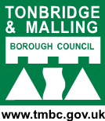 | Tonbridge and Malling Local Plan  Publication Stage Representation Form | Ref: (for official use only)

The Regulation 19 Local Plan consultation runs for six weeks from 11th September 2026 to 11.59pm on 26th October 2026. You can return this form to the Planning Policy Team at Tonbridge and Malling Borough Council, Gibson Building, Gibson Drive, Kings Hill, West Malling, Kent, ME19 4LZ.
Alternatively, you can return the form by email to localplan@tmbc.gov.uk.
Data protection and confidentiality
We are required to publish and make publicly available all comments submitted in response to this consultation. As such, we are unable to accept anonymous representations or representations from individuals who do not wish for their comments to be made public. Please note that representations submitted to the Council cannot therefore be treated as confidential.

In accordance with Regulation 22(1)(c) of the Town and Country Planning (Local Planning) (England) Regulations 2012, all representations received during the Regulation 19 Publication consultation will be submitted to the Secretary of State. This requires the Council to make publicly available copies of all representations received, together with the name of the individual submitting the representation and, where applicable, the organisation they represent.

All other personal information, including postal addresses, email addresses and telephone numbers, will remain confidential and will not be published.

As responses will be published, respondents are asked to ensure that all representations are respectful and appropriate. Comments that are racist, derogatory, offensive or inflammatory in nature should not be submitted.

Information about how the Council processes personal data can be found in the Data protection policy https://www.tmbc.gov.uk/council/data-protection-policy Please also note that information held by public authorities is subject to the provisions of the Freedom of Information Act 2000 and the Environmental Information Regulations 2004. Information may be disclosed in response to a request where it is appropriate and lawful to do so.

Please provide your details below to confirm acceptance of our privacy notice

Name:
Signature: | Date:
This form has two parts:
Part A – Personal Details. This only needs to be completed once if you wish to make more than one representation and representations are returned together.
Part B – Your representation(s). Please fill in a separate Part B form for each matter you wish to make a representation on.
We have also published guidance to assist you in completing this form. This can be accessed via https://reg19tmbcconsult.commonplace.is where you can alternatively complete your representation(s). Completing your representation(s) via our consultation platform is our preferred way for you to take part in the consultation.
The Planning Inspectorate have also released a guidance note on how to complete the form. https://www.gov.uk/government/publications/model-representation-form-for-local-plans/model-representation-letter-for-local-plans
Late representations
Representations received after the consultation deadline will be recorded as late representations. The Council is not obliged to treat these as duly made representations. However, late representations will be retained and forwarded to the Secretary of State as part of the submission documentation, clearly identifying them as having been received after the consultation period closed. The weight to be given to late representations is a matter for the appointed Planning Inspector.
Part A - This needs to be completed once if more than one Part B responses are returned together
 |  | - Personal Details |  | - Agent’s Details  (if applicable)
If an agent has been appointed by you, please complete only the Title, Name and Organisation (if applicable) in the boxes below (in Column 1), but complete the full contact details of the Agent in Column 2.
Title
First Name
Last Name
Job Title (if relevant)
Organisation (if applicable)
Address
Post Code
Telephone Number
Email Address

Part B – Please use a separate Part B form for each representation | Ref: (for official use only)

1: To which part of the Local Plan does this representation relate to?
This is important as it will be assessed by the Planning Inspector against the stated policy/section/site allocation. Reminder: If you would like to comment on more than one matter in the Plan, please complete a separate Form B for each matter you wish to make a representation on. We appreciate this takes additional time, but the Inspector requires comments to be submitted in this format.

Paragraph (please tick) |  | Policy |  | Policies Map

Which Chapter or Annex does this representation relate to?  (e.g Chapter 4) |  | 14
Which paragraph or Policy or aspect of the Policies Map would you like to make a representation on?  (e.g Paragraph 4.1 or Policy CC1) |  | 14.40
If your representation relates to a site allocation, please state which site. Please note you will need to make a representation for each site you wish to comment on.  (e.g. Site AN1) |  | BG1

2: Do you consider the Local Plan to be legally compliant? (Please tick)
Yes |  | No |  | Unsure

3: Please provide your comments here. Please also provide a summary of any attachments, such as supplementary evidence, submitted alongside your representation.
I have extreme concerns about the Greenbelt assessments and their conclusions, which having been drawn up by a Developer (Arup) and commissioned without Member input or oversight, rather than appoint a neutral consultancy which would have weighed loss of Greenbelt and North Downs National Landscape properly against the benefits of housing

Question 4: Do you consider the Local Plan to be sound? (Please tick)
Yes |  | No |  | Unsure

5: If you do not consider the Local Plan to be sound, please specify on what grounds (please select one option).
Positively Prepared |  |  | Consistent with National Policy
Justified |  |  | Unsure how to answer
Effective

6: Please provide your comments here. Please also provide a summary of any attachments, such as supplementary evidence, submitted alongside your representation.
I have submitted below a much more detailed statement, but the main issue is assessing Greenbelt whilst much of it is excavations still requiring landfill and restoration. We are very aware that Greenbelt by law only has to be "open and permanent", it does not have to be pretty or environmentally important. The concept of grey belt was introduced to allow development adjacent to rural settlements, and has removed what we used to call the "green wedge" policy. But according to those new NPPF rules, it is only villages that have had that protection, and the protection from encroachment into/from other settlements. But Planners have designated Borough Green as a Tier 2 Settlement in their hierarchy and have called us a "town", despite us being the smallest secular Parish in Kent. But on January 1st 2026 after an extensive public consultation Borough Green changed to Town status, which maintains our protection against encroachment and loss of that green wedge between our built environment and that of our neighbours

7: Please set out any modification(s) you consider necessary to make the Local Plan to be legally compliant or sound as relevant to the matter you have identified above. Please state why the modification you suggest will make the Local Plan legally compliant or sound. It would be helpful if you are able to put forward your suggested revised wording of any policy or text. Please be as precise as possible.
There are areas within BG1 that Borough Green in the past has supported for development that could give our residents the extra housing we need, the southern side of BG07 in the Arup Greybelt map below. It is important to remember that only the first few feet of BG07 and BG08 are within the 800 mtr walking distance of the Station and shops that are supposed to make the entire site sustainable

Please note: In your representation you should provide succinctly all the evidence and supporting information necessary to support your representation and your suggested modification(s). You should not assume that you will have a further opportunity to make submissions. This is because, after this stage, further submissions may only be made if invited by the Inspector, based on the matters and issues he or she identifies for examination.
8: If your representation is seeking a modification to the plan, do you consider it necessary to participate in the examination hearing session(s)? (Please tick)
No, I do not wish to participate in the hearing session(s)
Yes, I wish to participate in the hearing session(s) |  | 
9: If you wish to participate in the hearing session(s), please outline why you consider this to be necessary?
Because we believe the Green Belt assessment and its conclusion was deeply tainted by use of a developer rather than a neutral consultant, and we have had no oversight of their brief from Officers. We cannot trust Planning Officers give an accurate reflection of our concerns

Please note the Inspector will determine the most appropriate procedure to adopt to hear those who have indicated that they wish to participate in the hearing session(s). You may be asked to confirm your wish to participate when the Inspector has identified the matters and issues for examination. If you wish to participate in the hearing, please ensure that you have provided your telephone number in Form A.
BG1 Borough Green Gardens Greenbelt / Greybelt assessment
It is important to remember that whilst the area proposed by TMBC Planners for site BG1 is currently marred by multiple extraction sites, it is in fact part of the Holmesdale Valley stretching 16.5 Km from Sevenoaks through to Snodland and West Malling, rolling countryside dotted with tiny hamlets and woodland, and abuts the southern boundary of the North Downs National Landscape. It is as fundamentally important to the NDNL as the North Downs escarpment itself, complementing the view out of the NDNL, and providing sites for views into the NDNL.
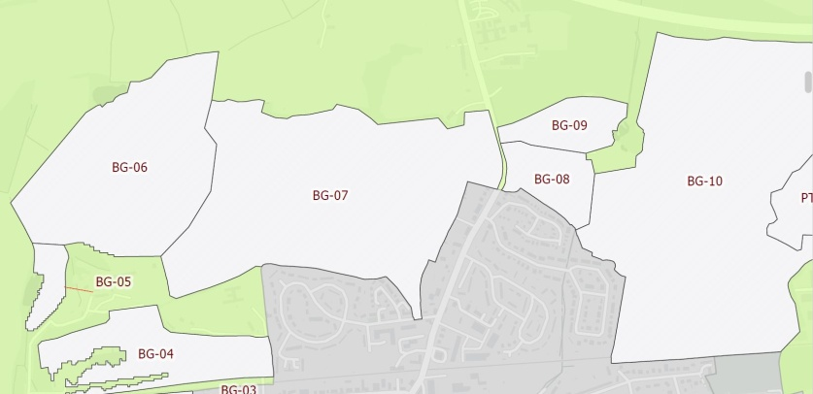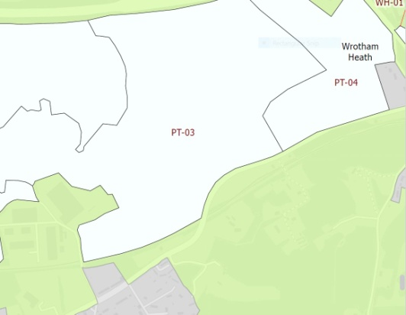
This plot numbers below are from the above Arup Greenbelt assessment map.
BG05 is currently largely dense woodland with a single track haul road through it, and it would cause severe harm to that woodland to build a Highway Standard road .
BG06 is Ightham Sandpit that used to supply material to the Sevenoaks Brick works on the H+H Celcon block factory site (BG04). Whilst a beautifully wooded wild area with ponds, it is actually an unregulated hazardous landfill site, completely unrecorded by TMBC, KCC or the EA.
BG07 is Robert Body's landfill site, but is better described as a family run building material recycling site, where hardcore, aggregates and sub-base are made by crushing builders waste. But the reality is they are still operating in a deep pit at the centre of the site, and whilst planners believe only that pit at the north needs to be filled, the restoration level is much higher between Westbank in the south and Westlands Farm in the north. It should also be noted that whilst the eastern end is sheltered from the north downs by the Potters Mede woodlands, the larger western section is in full view of the North Downs National Landscape, whose southern boundary abuts the northern boundary of the landfill site. The landfill is also the main "valley floor" view visible from the viewing points on Wrotham Hill in the NDNL.
BG08 can be discounted because it is wholly within the NDNL.
BG09, known locally as the Horsefield, but historically as the Water-Meadow, and is prone to flooding. But even more important is that the NDNL boundary runs diagonally across the site from the southwest to the northeast corners. Planners propose that grey belt development in the southeast half of the site would have no impact on the setting of the NDNL on the other side of a desire line footpath PROW MR251. Apart from the houses on Tolsey Mead to the south, the boundaries of the field are woodland. To the north east is the South East Water extraction borehole, that feeds a pipeline to the Ford Lane WtW.
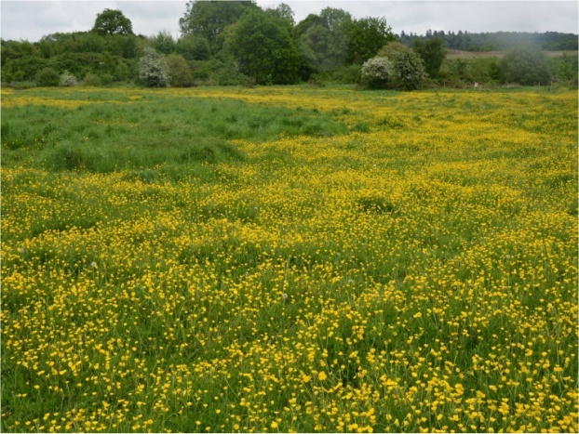
The woodland to the east of the site on rising ground is actually self seeded opportunistic colonisation of the overburden bund created temporarily by the extension to Borough Green Sandpit a couple of decades ago. It has become a natural area but if the bund were removed the view east is open as far as Botany Wood and the North Downs.
From BG09 the PROW wends through woodland until it opens out on to the open fields north of Borough Green Sandpits and becomes
BG10 This northern part of this land comprises two open fields with clear views across the hidden M26 to the North Downs, and along the scarp of the Downs as far as Snodland. (I often use the picture below as my Teams background when talking to Officers, because it highlights what will be lost if Borough Green Gardens go ahead). There are two mature trees in the centre, the wood to the right is Botany Wood, protected Ancient Woodland, but the most important element is the view east along the North Downs Escarpment. Never mind the carpet of wild flowers, this view is the very definition of the Openness that is Greenbelt.
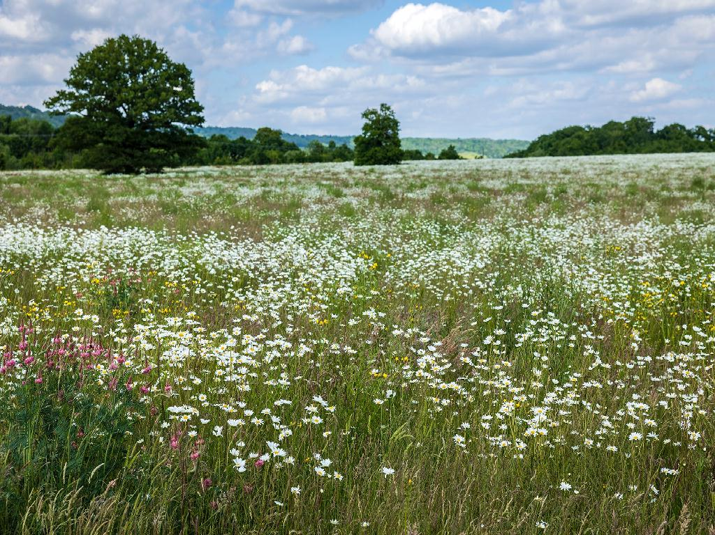
But to continue with the southern half of BG10 we have Borough Green Sandpits. How can any Greenbelt Assessment that puts this beautiful field above in the same parcel as this sandpit below be treated as a balanced rigorous scientific report?
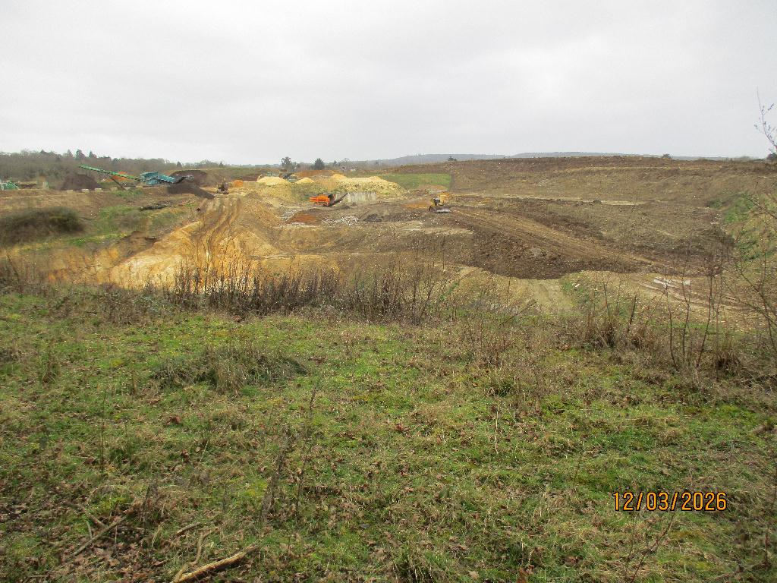
The north eastern arm of BG10 is known as Park Farm Quarry. This was a claypit supplying Rugby Cement at Halling until they closed down. There is an extant permission to extract the sand below, and a more recent application to extract the remains of the clay. But the site cannot be realistically assessed for its greenbelt contribution until it is restored as per its planning conditions. This view is looking north towards the NDNL and the scarp is clearly visible - Open Greenbelt
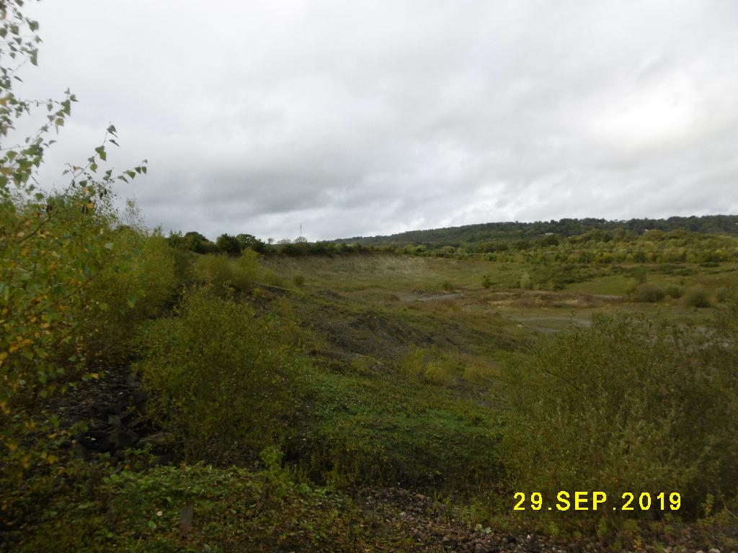
BG10 Park Farm cont/ It is also extremely relevant that Park Farm Quarry cannot be developed at its current levels. The residue of clay and any future hard standing development would prevent drainage into the ground, and without significant investment the area would soon flood.
It is also extremely relevant that Nepicar Sandpit until very recently had an extant approval to put a haul road through to Park Farm to extract the sand. Whilst that permission was recently surrendered, the majority of that haul road is in fact in place as the access to the Nepicar Western Extension. Four trees and a weekend's work with a digger and they can access Park Farm Quarry.
PT03 is Nepicar Sandpit, separated from BG10 and Park Farm Quarry by Ancient Woodland, Firemanshaw Wood. Nepicar Sandpit is a huge excavation, and should not be assessed for its contribution to Greenbelt until it has been restored to pre-extraction levels. This could be some decades, not just because of the current excavation, but there is an application to extend west towards Platt Industrial Estate, which will involve significant remediation of asbestos in part of that site known as "The Pit". This remediation will involve contaminated material to be handled and safely stored in the current Nepicar Sandpit to seal away the contamination before any reinstatement.

PT04 is open land owned by De Merke between Nepicar Sandpit eastern boundary and the A20 at Nepicar. It is currently within the KMWLP Mineral Safeguarding Area for Soft Sand extraction, and that status was confirmed in November 2021, and reinforced by KCC's robust response to the Reg 18 Consultation where they expressed their concerns about TMBC's cavalier disregard for the importance of sand and aggregate as local materials needed for the proposed housing. This area is directly abutting Nepicar, and current workings could be very easily extended east - saving loss of virgin land elsewhere.

TOWN STATUS
We noted the reports in September 2025 that Solihull Metropolitan Borough had invoked Town Status to prevent 4 villages being coalesced into the urban sprawl.

Borough Green Parish Council Agreed Minutes January 2026
312 Town Status
(i) Councillors Butterfill and Reid have checked all submissions before the meeting, online, paper copies and emails, and the Clerk announced those results as: Change to Town Status, YES 375 NO 200 Undecided 17 The Chairman then proposed the below:
(i) That Borough Green declares Town Status effective 1st April F/YE - AGREED Unanimously
(ii) That decision will be subject to 6 monthly reviews - AGREED Unanimously
(iii) That the Clerk is Authorised to change our Bank Account names to "Borough Green Council" and once that is in place we can adopt Town Status - AGREED Unanimously

NPPF 2024 - Greenbelt has to be Open and Permanent
143. Green Belt serves five purposes:
a) to check the unrestricted sprawl of large built-up areas;
b) to prevent neighbouring towns merging into one another;
c) to assist in safeguarding the countryside from encroachment;
d) to preserve the setting and special character of historic towns; and
e) to assist in urban regeneration, by encouraging the recycling of derelict and other urban land.
Greenbelt land has to score badly against criteria a, b, & d to be deemed suitable for designation as Grey Belt..

Criteria a) Borough Green is distinct from its neighbours in that we are intensely developed virtually to our boundaries, as densely populated as any city borough.
Whilst Borough Green is not large in comparison with Tonbridge, we are a large built up area in relation to our tiny neighbours in Wrotham , Platt, Ightham, Plaxtol and Stansted. So we contend we score highly against criteria (a) in that development of BG1 would bring us in direct contact with the southern boundary of Wrotham Parish's built up area on Borough Green Rd.
We understand at the moment there is no legal definition of what constitutes a "Large Built Up Area" or a "Town" - we contend that until a legal precedent is set we are justified in claiming that status. It is also very relevant that in the TMBC Settlement Hierarchy we are deemed to be a Tier 2 Town, whereas our size as the smallest village in Kent by land area should make us a Tier 4 or 5.

Criteria b) Whilst Ightham, Wrotham and Platt are not Towns, BG1 will lead us to merge with those three villages. Whilst not a complete achievement, I think it merits a medium strength score for criteria (b).

Criteria c) Apart from a spattering of Listed Buildings, Borough Green has no Historic Character. But our neighbours in Ightham Platt and Wrotham all have strong Conservation Areas, and coalescence with the urban area of Borough Green would cause huge impact to those Conservation Areas. It is the case that the approach through a rural community towards its Historic Conservation Area is almost as important as the area itself, it is an important part of the setting of the Conservation Area.

We therefore disagree with the Arup Assessment, and that our Local Greenbelt in the area called BG1 actually scores between medium and high, it is Open and Permanent, and therefore does not fulfil the requirements for re-classification or designation as Grey Belt.

