 | Tonbridge and Malling Local Plan  Publication Stage Representation Form | Ref: (for official use only)

The Regulation 19 Local Plan consultation runs for six weeks from 11th September 2026 to 11.59pm on 26th October 2026. You can return this form to the Planning Policy Team at Tonbridge and Malling Borough Council, Gibson Building, Gibson Drive, Kings Hill, West Malling, Kent, ME19 4LZ.
Alternatively, you can return the form by email to localplan@tmbc.gov.uk.
Data protection and confidentiality
We are required to publish and make publicly available all comments submitted in response to this consultation. As such, we are unable to accept anonymous representations or representations from individuals who do not wish for their comments to be made public. Please note that representations submitted to the Council cannot therefore be treated as confidential.

In accordance with Regulation 22(1)(c) of the Town and Country Planning (Local Planning) (England) Regulations 2012, all representations received during the Regulation 19 Publication consultation will be submitted to the Secretary of State. This requires the Council to make publicly available copies of all representations received, together with the name of the individual submitting the representation and, where applicable, the organisation they represent.

All other personal information, including postal addresses, email addresses and telephone numbers, will remain confidential and will not be published.

As responses will be published, respondents are asked to ensure that all representations are respectful and appropriate. Comments that are racist, derogatory, offensive or inflammatory in nature should not be submitted.

Information about how the Council processes personal data can be found in the Data protection policy https://www.tmbc.gov.uk/council/data-protection-policy Please also note that information held by public authorities is subject to the provisions of the Freedom of Information Act 2000 and the Environmental Information Regulations 2004. Information may be disclosed in response to a request where it is appropriate and lawful to do so.

Please provide your details below to confirm acceptance of our privacy notice

Name:
Signature: | Date:
This form has two parts:
Part A – Personal Details. This only needs to be completed once if you wish to make more than one representation and representations are returned together.
Part B – Your representation(s). Please fill in a separate Part B form for each matter you wish to make a representation on.
We have also published guidance to assist you in completing this form. This can be accessed via https://reg19tmbcconsult.commonplace.is where you can alternatively complete your representation(s). Completing your representation(s) via our consultation platform is our preferred way for you to take part in the consultation.
The Planning Inspectorate have also released a guidance note on how to complete the form. https://www.gov.uk/government/publications/model-representation-form-for-local-plans/model-representation-letter-for-local-plans
Late representations
Representations received after the consultation deadline will be recorded as late representations. The Council is not obliged to treat these as duly made representations. However, late representations will be retained and forwarded to the Secretary of State as part of the submission documentation, clearly identifying them as having been received after the consultation period closed. The weight to be given to late representations is a matter for the appointed Planning Inspector.
Part A - This needs to be completed once if more than one Part B responses are returned together
 |  | - Personal Details |  | - Agent’s Details  (if applicable)
If an agent has been appointed by you, please complete only the Title, Name and Organisation (if applicable) in the boxes below (in Column 1), but complete the full contact details of the Agent in Column 2.
Title
First Name
Last Name
Job Title (if relevant)
Organisation (if applicable)
Address
Post Code
Telephone Number
Email Address

Part B – Please use a separate Part B form for each representation | Ref: (for official use only)

1: To which part of the Local Plan does this representation relate to?
This is important as it will be assessed by the Planning Inspector against the stated policy/section/site allocation. Reminder: If you would like to comment on more than one matter in the Plan, please complete a separate Form B for each matter you wish to make a representation on. We appreciate this takes additional time, but the Inspector requires comments to be submitted in this format.

Paragraph (please tick) | 14.35 - 14.53  +pp 426-429 | Policy |  | Policies Map

Which Chapter or Annex does this representation relate to?  (e.g Chapter 4) |  | Chapter 14  Development Allocations BG1
Which paragraph or Policy or aspect of the Policies Map would you like to make a representation on?
(e.g Paragraph 4.1 or Policy CC1)
If your representation relates to a site allocation, please state which site. Please note you will need to make a representation for each site you wish to comment on.  (e.g. Site AN1) |  | BG1, 59830 - Borough Green Garden City

2: Do you consider the Local Plan to be legally compliant? (Please tick)
Yes |  | No |  | Unsure

3: Please provide your comments here. Please also provide a summary of any attachments, such as supplementary evidence, submitted alongside your representation.
As noted in the evidence below, the site is unavailable and undeliverable.
If deemed unsound the loss of the 2000 (3000) houses would render the entire plan unsound. It is worthy of note that the original 2017? Call for sites calculated 4128 house under less stringent density rules.
It is also easily established that the vast majority of the site, except for those parts adjacent to Wrotham Road are outside the policy 800mtrs walking distance to shops and railway.

Question 4: Do you consider the Local Plan to be sound? (Please tick)
Yes |  | No |  | Unsure

5: If you do not consider the Local Plan to be sound, please specify on what grounds (please select one option).
Positively Prepared |  |  | Consistent with National Policy
Justified |  |  | Unsure how to answer
Effective

6: Please provide your comments here. Please also provide a summary of any attachments, such as supplementary evidence, submitted alongside your representation.

Detailed analysis of all the contributing elements of the site below

7: Please set out any modification(s) you consider necessary to make the Local Plan to be legally compliant or sound as relevant to the matter you have identified above. Please state why the modification you suggest will make the Local Plan legally compliant or sound. It would be helpful if you are able to put forward your suggested revised wording of any policy or text. Please be as precise as possible.

There are no modifications that can be made to make the site or the Plan legally compliant or sound - the cumulative impact of all the problems with the different elements makes it undeliverable, except for a small area south of BG Landfill, sites 311 & 312 in the old plan that could yield some 3-400 houses, and has the support of the Parish Council as sustainable and adequate for our needs.

Please note: In your representation you should provide succinctly all the evidence and supporting information necessary to support your representation and your suggested modification(s). You should not assume that you will have a further opportunity to make submissions. This is because, after this stage, further submissions may only be made if invited by the Inspector, based on the matters and issues he or she identifies for examination.
8: If your representation is seeking a modification to the plan, do you consider it necessary to participate in the examination hearing session(s)? (Please tick)

No, I do not wish to participate in the hearing session(s)
Yes, I wish to participate in the hearing session(s)

9: If you wish to participate in the hearing session(s), please outline why you consider this to be necessary?

We are extremely concerned that TMBC officers and legal representatives may not present a fully compliant justification for the inclusion of this site, and feel making our own representations with our neighbours in Ightham , Platt and Wrotham will give the Inspector the real narrative behind this site. It is home to us, it is just a blob on paper to them.

=========================================================================================
BG1 59830 Borough Green Garden City
An assessment of availability and deliverability

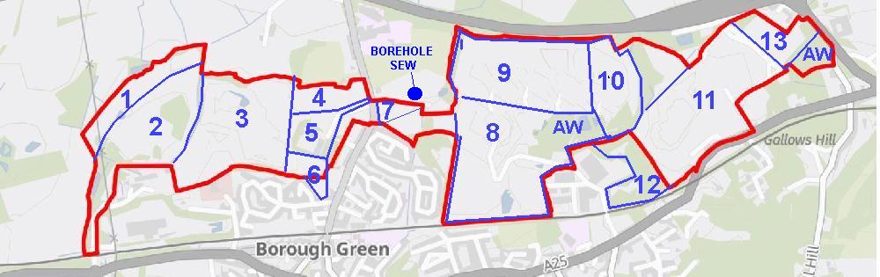

Map 1. BG06 Ightham Sandpit - North Western arc
This is the area that was not included in the Southern Testing 2006 Intrusive Ground Investigation.

Map 2. BG06 Ightham Sandpit - Main Sandpit
This area was investigated by Southern Testing for BG&P Bypass and Celcon 2 Factory 2003 application, and the intrusive survey estimates some 200,000 cu mtrs of contaminated and hazardous fill. Celcon had contracted Trodell Plant to complete excavations at ISP, and to backfill and restore, including forming the area for a new Block Plant and the BG&P Bypass between the late 80s and mid-90s. Vast quantities of hassock from Isles and Stangate Quarry were excavated for the purpose, but the bulk disappeared from the site onto the open market, and the fill was replaced with material from the BP Isle Of Grain refinery remediation, and possibly also Greenwich Gasworks, the site of the O2 arena. This knowledge is almost exclusively anecdotal from industry insiders. Neither Trodell or Celcon ever applied for reinstatement permission, and so neither KCC nor the EA have any record of the landfill and there are no records of materials used. The EA do not even record it as a historic landfill site.
TMBC Planners may have made an error in assuming that the north western arc is clean, not realising that the entire site was landfilled at the same time with the same material, but only the Bypass and Factory application site were investigated and the contamination map only shows that reduced area. By proposing the Relief Road runs through the North Western Arc planners are assuming this will avoid contamination.
The report was included in Disclosed Evidence in 2007 to Wrotham PC as a Rule 6 party to the Celcon Inquiry, but the application was withdrawn before it was lodged as inquiry evidence.
Whilst neither the NDNL status nor contamination physically block construction of the Relief Road for BGGC, there is a high risk of contamination to the aquifer that may require an immediate remediation program.

Submitted Plan Planners Reg 18 edit Survey Borehole Map ISP
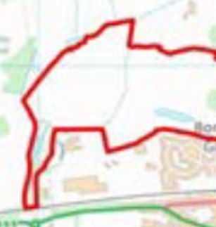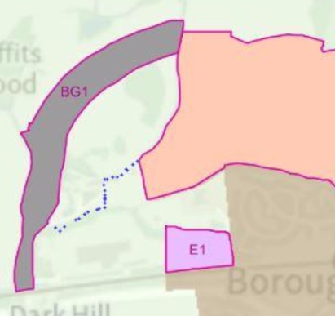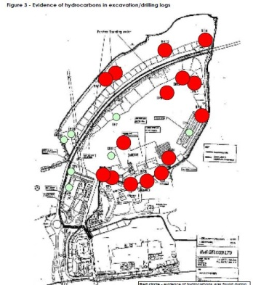

Map 3. BG07 Robert Body BG Landfill -Western end
One of the most important features of the North Downs National Landscape in this area is not its internal landscape, but the views out and down the escarpment into the Holmesdale Valley. Area 3 is not shielded by the Ancient Woodland at Potters Mede, and any development in Area 3 will have a severe impact on the setting and views out of the NDNL. Whilst some mitigation can be applied the height of the North Downs viewpoint means that the development will still be clearly visible over the tops of any new trees. (see pic)
The view of the Holmesdale Valley and Borough Green from Wrotham Hilltop in the NDNL

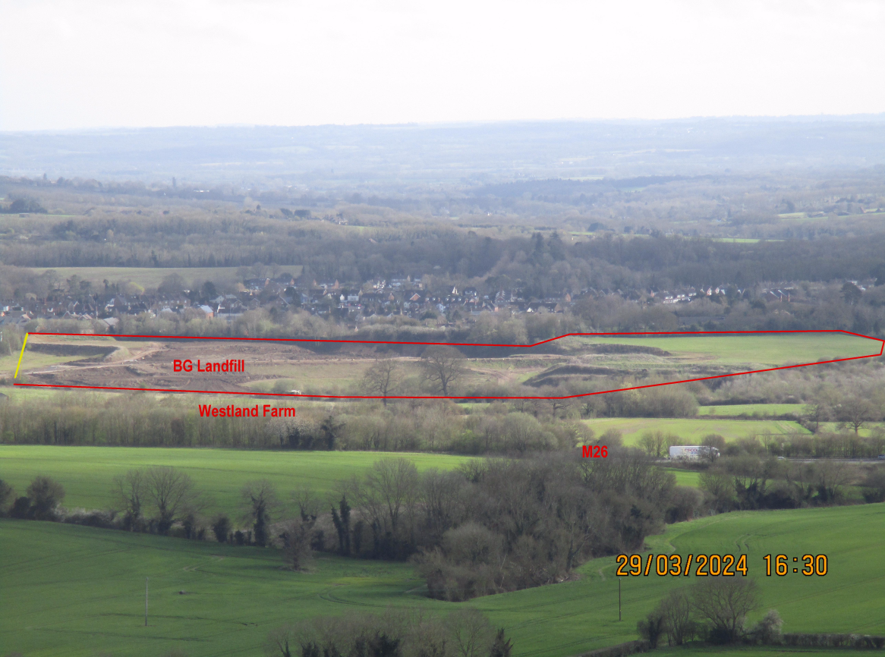

Map 4. BG07 Robert Body BG Landfill - North East section - POW Camp
This north east corner was not excavated when Halls reached that point, and the excavations turned west towards ISP. At this time there were buildings on this part of the site that were either a WW2 camp for POWs or displaced Europeans. It cannot be deemed PDL because they were demolished in the 70s.

Map 5. BG07 Robert Body BG Landfill - Employment Area
The employment use here is well established back to the mid 1800s when it was a town gas plant, later a fencing and fabrication factory. RB has invested significantly in new buildings and there is a small industrial estate there. There is likely to be serious PAH/coal tar contamination there from coal gasification residues.

Map 6. BG07 Robert Body BG Landfill - Housing Area supported by BGPC
This area and the triangle towards Fairfield Rd is supported as housing development by BGPC/BGTC and should provide about 200 houses proportionate to our local need. It will also provide a roundabout on the A227 making site access much safer, and providing a natural brake on high speed traffic coming south into Borough Green
It is also important to remember that whilst Robert Body's family own this site and run a successful groundworks and recycling operation here, there is an overage clause held by Cemex. So there is no incentive for RB to have houses built here, and whilst it is a busy operation, most of the inbound material is in fact recycled and sold back on - I suspect we may be looking at 15 years at least before the landform is restored.

Map 7 BG08 Horsefield - east of A227 Wrotham Rd
This field is a real anomaly - the north west triangle is NDNL and Greenbelt, the south east is just greenbelt, separated by a dirt desire line footpath. I do not believe it is possible to build houses on the southeast section without a severe impact on the setting of the NDNL in the other half of the field, and the views into and out of it. We accept that a road could be built across it, apart from the recent upgrade to NL rules requiring Protect and Enhance.

Map 8 BG10 Borough Green Sandpit inc Botany Wood (AW)
Borough Green Sandpit is now approaching completion, with backfill well underway. Parishes would not have a problem with the land north of Platt Industrial Estate being used for employment development, particularly if the 2016 new access road permission was implemented. Botany Woods is designated Ancient Woodland .

Map 9 BG10 Borough Green Sandpit - Northern Fields
It is clear from the way that BGSP have been "nibbling" at their northern boundary that the area up to the M26 is also a strong sand resource. There is an acknowledgement in mineral circles that it is better to extend existing works rather than open up new pits in virgin land. The clay overburden here varies between 10 and 15ft, but would be a useful resource landfilling other parts of the site. Owned by Echoraise Ltd K971450

Map 10 BG10 Park Farm Quarry
Was originally opened to use the clay overburden for the Rugby Cement Works at Halling, now largely worked out, but it still has an extant permission for sand extraction until 2042. Owned by Echoraise Ltd K975410

Map 11 PT03 Nepicar Sandpit
Any belief that Nepicar sandpit can be fully excavated and restored within the time frame of this Local Plan (or the next) is a very mistaken assumption. A simple site visit will establish that it is vast, Grand Canyon scale. It is also relevant that the Western Extension application going through KCC Minerals at the moment will delay restoration of the main pit.

Map 12 PT03 Nepicar Sandpit - Western Extension application area
There appears to be no reason this extension will not be permitted - whilst not yet dire there is a shortage of building sand and the huge increases in Government Housing demand will mean current reserves will quickly become inadequate.
Nepicar sandpit did apply for a haul road through to Park Farm to access the sand there, but withdrew that application when they applied to lower the base on the main pit. But they won't now need a fresh application to access Park Farm, because the Western Extension directly abuts Park Farm Quarry - they can just keep excavating north on the extant permissions.

Map 13 PT04 De Merke/Martin Cavalier land - exit to A20 Nepicar
Whilst this gentleman is a member of the Consortium the price he may try to extract for his land may be too high even for them. Notwithstanding that issue, this land is within the KCC Minerals Soft Sand Safeguarding Area, which means no development will be allowed that might sterilise those reserves. KCC reaffirmed in 2022 that they would not be removing that safeguarding, and you will recall that their Statutory Consultee response to Reg 18 took TMBC to task for not properly considering Mineral Safeguarding areas. Owned by De Merke K572715

Section 14 Greenbelt/Greybelt assessment
This survey is deeply flawed, as Members have pointed out on several occasions - it beggars belief that of all the sites surveyed, only two at West Malling were deemed worthy of being retained as Greenbelt, most of the rest were condemned as Greybelt "low contribution to Greenbelt purposes". The main purpose of Greenbelt as enshrined in the original laws, was to be "permanent and open", it does not have to be pretty or full of wildlife, or have public amenity accessibility - it just needs be permanently open. I have several issues with the report:
a) It mixes open greenbelt with quarries still being worked, detracting from the value of the open land.
b) it has been drafted by Arup who are a major developer , and so is skewed towards removing land from
Greenbelt for development rather than assessing its real contribution. It would have a far stronger evidence value
if it had been carried out by someone with a Natural Environment qualification.
c) It makes no reference to the fact that quarries have to be restored to their original status - open greenbelt.

NPPF 142. The Government attaches great importance to Green Belts. The fundamental aim of Green Belt policy is to prevent urban sprawl by keeping land permanently open; the essential characteristics of Green Belts are their openness and their permanence.
143. Green Belt serves five purposes:
a) to check the unrestricted sprawl of large built-up areas;
b) to prevent neighbouring towns merging into one another;
c) to assist in safeguarding the countryside from encroachment;
d) to preserve the setting and special character of historic towns; and
e) to assist in urban regeneration, by encouraging the recycling of derelict and other urban land.

If the BG Landfill and the Horsefield are developed, apart from impacting the openness and permanence of the Greenbelt, it clearly breaches the guidance (a) - BG is a heavily built up area, (b) It would allow BG Town to merge with the built environment of Wrotham, (c) It obviously encroaches on the countryside.

Section 15 Relief Road LP Reg 19 Chapter 14 paras 14.47 & 14.48, and Chapter 5 para 5.31
Borough Green and its close neighbours have suffered 150 years of quarrying, sandpits, claypits and landfill sites, and the huge numbers of HGVs that has generated. We have done our bit in the national interest, and simple fairness demands that we now get the rural peace other villages in TMBC and beyond have enjoyed over those centuries.
We currently experience 20,000 vehicles a day through our village, with a far higher proportion of locally generated HGV traffic than other places. The only benefit whatsoever to Borough Green is for the Relief Road to be built first to take this traffic out of the villages, and for all construction traffic building 3000 houses to be routed here as well.

The "error" that led to the wrong wording in the BGGC section of the Reg 18 has now been rectified, with no development of BGGC allowed until the Relief Road is complete. This has been unequivocally confirmed by the Leader, the Chief Executive and the Cabinet Member for Planning. This wording must not be accidentally edited again, it will read :
“This includes a relief road from the Ightham bypass (A25) to the A20, to be delivered in advance of the development based on the current transport evidence”.
The risk of the Planners' approach is that Borough Green and its neighbours will be subject to decades of piecemeal development over the next 30 years without getting a Relief Road until the end.
The Relief Road will not be the panacea we are told. Traffic that avoided the main congestion hotspot at Nepicar M26 by turning east at Wrotham Heath, or north at Whitehill, will now all join the A20 at Nepicar, where it will have to fight its way back to its original route. This will be aggravated by the new traffic generated by Moto just north of the M26 roundabout

Section 16 Development Partners
It has been put to me that BGGC has some confirmed status ahead of the other Strategic Sites because it has a "Development Partner" which is intended to mean it will go ahead whatever. Officers have steadfastly refused to reveal the name of either the first or the second "Development Partner", until Eleanor slipped up and mentioned it was Vistry - you can imagine my unbridled joy when they immediately went bankrupt. The reality is that having a Planning Advisor or a Development Partner means nothing, only that they are willing to step up if and when the allocation gets approval. And whilst they are happy to take Consortium money to put a case together, I bet they are not putting their own money in.

Section 17 Town Status
Borough Green ran a public consultation in November December 2025 and as a result of significant public support declared Town Status on 5th January to take effect on the 1st April 2026.
The main reason for this is that Government changed the rules preventing the coalescence of settlements, the so called green wedge policy. The change removed that protection from parishes, but not towns. ( See Solihull Metropolitan Borough Council) It may well be that by now, or in the future, the Government may have yet another re-jig of the rules. But in the meantime we believe that allowing BGGC development on the Robert Body site west of the A227, or the Horsefield on the east of the A227 , would allow the built environment of Wrotham and Borough Green to coalesce and we would be merged. It will also allow the large built up area to expand without limit, and further encroach on our vanishing countryside. We do not know if Town Status will work, but it cost us nothing to implement, and we can revert with a simple vote at Council, which we will do because we value our Parish Status. There would be a delicious irony if it did work, planners have been so dead set on calling our tiny village** a town in their settlement hierarchy, if town status turned out to actually protect us from development….
**Borough Green is the smallest village by area in TMBC, and the most densely populated

Section 18 Aquifer and Borehole - Source Protection Zones.
There is a SE Water extraction borehole and plant just north of the Horsefield, pumped across country to the Ford Lane treatment works at Trottiscliffe. The main protection zone is directly beneath the Horsefield and BG Sandpits, the secondary area runs north and south around that, but the main aquifer lies beneath all these quarries and sandpits. Any development of landfill sites will require deep piling for stability, as did Isles Quarry West. That creates a real risk of contaminating our aquifer with buried contaminants, and it's important to remember that all these quarries except Nepicar go back before the war , and some into the 19th century. Whilst modern backfill operations are engineered and use inert waste and cell construction, that was not the case in the past - they will all have unknown areas of historic contamination. The map below shows the BGGC borehole and Ford Lane - the only part of the BGGC not in some element of the Horsefield SPZ are the fields north of BGSP and Park Farm Quarry, and they are in the Ford Lane SPZ.
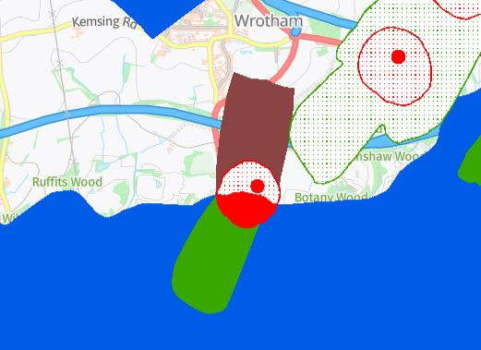

Section 19 Sewage and Water infrastructure
Water supply issues are at the top of the news, and it is difficult to see the Government coming up with a strategy that resolves the water supply and allows the quantum of housing demanded. I suspect we will see them fudge a policy. SEW do have plans in place that will allow 8000 houses by 2042, but that margin is already taken up with the windfall/extant/build out housing - the extra 12000 cannot be accommodated. Even if we make the false assumption that aquifers are infinite I suspect the provision of the required infrastructure, boreholes, treatment and pumping stations, reservoirs and pipe work will arrive long outside the time frame of this Plan.
It is also extremely relevant that recent Environment Agency figures supplied to TMBC show that the Greensand Ridge aquifer is severely depleted, and that aquifer supplies most of the north of the Borough. It is also very important to remember that the hazardous waste site at BG06 Ightham Sandpit sits right over the top of this aquifer, that extends virtually through to Maidstone.

Sewage failures in Borough Green caused by decades of increasing demand on a collapsing system built in 1929 have been a long standing problem. Whilst it is true SW have recently managed the system without a major breach, the system is operating close to absolute capacity as witness the permanent smell of sewage on Wrotham Rd near Tolsey Mead, the Maidstone Rd pumping station, and Askew Bridge on the A25. The smell in these places can be so strong it is noticeable in a passing car. (See Chap 13 response)

Section 20 Historic Landfill
As noted in the recent TMBC Informal Landfill Register, submitted to the Plan through the PPP, Borough Green is surrounded by historic landfill sites.(see map at end) Today's landfills are built from the bottom up using carefully tested inert fill, quite often divided into cells and capped with clay. Both the EA and KCC Minerals have stringent monitoring and recording protocols in place, including CCTV. These landfills are compacted layer by layer meaning we end up with a stable and clean site. Until very recently waste was tipped into a pit from the edge, unmonitored, with inert, industrial, hazardous, contaminated and even domestic waste mixed at random. It was allowed to compact under its own weight, which results in voids, perched water, putrescible waste which rots and creates methane and more voids, and an unstable and contaminated product with the endless problems witnessed at Isles Quarry West. Using stockpiling compaction, band drains, and spot excavations, some of the problems can be dealt just below the surface, but don't reach deep enough. The only option then is to deep pile, which apart from serious noise pollution risks disturbing pockets of contamination and releasing it into the aquifers.
Recent restoration at BGSP (pre WW2) and BG Landfill (1880s) have been carried out under modern rules, but they both have significant pockets of land that were backfilled much earlier without modern controls.

Section 21 Sustainability
Sustainability is one of these elastic words that means what the speaker intends. It is true that a small part of BGGC is within 800m walking distance of a train station and other amenities, ignoring the fact that 3000 new homes will place such a burden on that station it will become unviable - they won't walk, they will drive, and whilst perhaps 20 extra spaces could be provided on the Rail Contractor depot to the north that is not enough to cope with the demand. The nearest open space that could be used as a carpark for the Station is within BGGC itself.

Section 22 Settlement Hierarchy
The decision to put Borough Green in the upper levels of the Settlement Hierarchy was clearly driven by the wish to develop Borough Green Garden City. Borough Green and its neighbours are blessed with a viable retail area, a Medical Practice, a Dentist, a Library, Schools, a station and bus services. But these facilities operate at capacity now and exist in a very delicate balance, just fulfilling current needs but without spare capacity, and nowhere to expand. The supreme irony are the buses - we technically have 4 routes. Two of those were withdrawn three years ago, and now operate one day a week funded by the Parishes. The other two have seen dramatic reductions in service In the past few years, and we are already negotiating to add those to our Shopper Bus service. As noted above, the station operates at capacity now and has no room for any meaningful expansion. We are already talking to KCC about taking on the Library when the next round of cuts starts.

Section 21 OAN
In 2016 the ONS settled an OAN on TMBC of about 7000 homes, 50% local need and refugees, 50% "Internal migration". While Steve Humphrey and Ian Bailey were struggling to find sites for this volume of housing, the Consortium gave them a Plan for 3000 houses, 43% of the whole OAN. That was seized without query, but by the time they realised they had been conned into accepting an undeliverable site, it was politically too late to change the Plan. And here are TMBC ten years later still trying get that undeliverable site into the Local Plan. The genuine local need of 3500 houses has increased only slightly year on year, the massive increase in numbers comes from successive Governments doomed attempts to lower house prices and boost the economy. But developers will never build enough houses to have any real effect , they won't risk their profit margins.

Section 22 Conclusions
I do not wish this catastrophic level of housing on any settlement in TMBC, but I have always been baffled by Planners insistence on keeping a clearly undeliverable site in the plan as a Strategic Site when there are other greenfield sites that could be built on tomorrow.
Whilst developers and planners might prevail on the Inspector to allow the Relief Road to be delivered piecemeal when the BG Landfill, BGSP, Park Farm, Nepicar and the Martin Cavalier land have been filled and restored - there is one remaining obstacle - the new sewage pumping stations and connection to Snodland have to be completely in place before a single house can be built - that can only be built when the landform is completed.
Planners talk about adhering to the evidence, but parts of the evidence base such as Settlement Hierarchy, Sustainability, Green/Grey assessment, Transport, Source Protection and Contaminated Landfills have been clearly manipulated to keep this site at the top of the list. - Why?
-------------------------------------------

Borough Green Landfill sites
